The Development of a Functional Multiplayer Shooter – The Report:

*References to the appendix are enclosed in brackets and in italicized bold.*

At the start of the summer of 2017, I began to conceive plans for an ambitious project. A project that would unite technical and creative expertise: to produce a fully functional online multiplayer game.

The game is named ‘Space Quest 2099’, an intentionally cheesy title chosen to parody a number of pre-existing sci-fi franchises. It is a team based first person shooter in which players join one of two sides (Engineering or Command) comprised of three character classes, each with their own strengths and weaknesses, battling for control of their spaceship – The Thunderchild - for unknown reasons. The game revolves around teams gaining control of certain parts of the ship, called territories ***(Level Design - The Map).*** A winner is determined when the ship is fully controlled by one team.

Over the course of the project I gained the opportunity learn about and make use of a wide range of mathematical and computing techniques through exposure to tasks I have never before undertaken, such as three-dimensional vectors, state machines, and Euler angles; used for calculating weapon hit co-ordinates ***(Bullet Spread)****,* character animation ***(Animation)****,* and camera aim angles respectively ***(Animation – Euler angles)****.*

Inspiration was initially sparked by a case study of the game ‘Deserts of Kharack’, delivered by Blackbird Interactive at the Unite conference. It covered the challenges the development team had faced in creating the game’s multiplayer component **(Blackbird Interactive, 2016).**  I found this particularly interesting, therefore I decided to attempt to create my own multiplayer game with anticipation of overcoming my own personal challenges.

Secondary Research:

A mixture of primary and secondary research was carried out prior to and during development. The primary research I carried out is detailed in the technical appendix; it consists of solutions to problems I personally developed. The project commenced with a large amount of secondary research, covering areas such as network topology to level design theory **(Valve Corporation 2014)**, allowing me to begin to formulate ideas before starting production.

I deemed basic game and network functionality to be the most important area on which to initially focus; not only would this provide the foundation upon which to build the rest of the game, but also would offer me an appreciation for the technical limitations that may be encountered. To do this, I followed a tutorial set created by Martin Glaude which gave an excellent introduction to establishing fundamentals of an internet based multiplayer game **(Glaude M, 2013)**. This introduced me to the Photon Unity Networking plugin, a valuable client-server communication tool which I otherwise may not have discovered. **(Photon, 2017).**

The nature of the project shifted drastically once the network and data transmission methods had been set up, moving towards more creative areas such as level design, where I was able to make use of a wide range of sources. I found Valve’s developer commentary **(Valve Corporation 2007)** to be a particularly valuable source during this process as it gave vital insight into map design from professional developers. Through this, I learned key environmental artistry concepts such as varying use of textures and lighting to emphasise a location ***(Level Design – The Territories and Their Artistic Direction)*.** From a gameplay perspective, I was able to adapt some of their ideas into my own designs and create a map that was not only visually interesting, but also fun to play ***(Level Design - Gameplay Level Design).*** For the sheer amount of resources Valve released, I decided to use Team Fortress 2 as somewhat of a case study for Space Quest.

Primary Research

Due to the nature of the project, traditional forms of primary research such as paper based surveys with specific questions were not used. My primary research consisted of gameplay tests with focus groups, in which I would record their opinions and suggestions to write to a testing report. With this information, appropriate amendments to the game were made ***(Multiplayer Testing Reports)****.*

Other work I place under the category of primary research is experimentation with scripts, as it concerns solutions to problems I personally developed. I found it very useful to write up my next task in a detailed paragraph, as if I were explaining it to somebody. This process provided me with clarity of thought necessary for designing some of the more advanced scripts such as the interpolation co routine ***(Clearly Written Plans)****.*

Time Management:

As part of the extended project, I had to take consideration of time management. Whilst working on a large project, such as this, it was essential that time was managed effectively to allow for leeway if extraneous reasons caused for deadlines to be missed. My primary method of timekeeping was a project timeline of development. This timeline featured key deadlines with proportional areas denoting time periods. Another example of time management was my reflective progress log. This allowed me to keep track of tasks that had been completed on a weekly basis, as well as provide a small evaluation to my work, providing a basis for next week’s aims. The project timeline was followed loosely; using the leeway planned into its design - I knew that there would be times at which A-Level work and other commitments would take priority from the extended project. The project’s progress of development started out at high rate; due to a mixture of a strong starting enthusiasm for the project and the lack of bug occurrence early on, resulting in deadlines being met consistently and sometimes early. Once the highly technical first stage of development had been completed, involving setting up the fundamental protocols and scripts, progress began to slow. The large amount of level design ahead of me, coupled with the completion of must technical work, caused my enthusiasm to waiver and for self set deadlines to occasionally be missed. This made my original timeline somewhat obsolete. Other times I would simply be unable to complete any work on the project due to the amount of time it took to bake lightmaps – the intense batch processing calculating the lighting for a scene would render my computer out of action for days at a time.

Justification of Software:

A major obstacle for this project was the steep learning curve required for independently creating games with professional software. However, I have had past experience with the Unity Engine having been a hobbyist for several years, allowing me to mitigate the hurdle of learning C#. This is the main reason I decided upon using Unity over its main competitors such as Unreal Engine or Cryengine, as I believed it would be too great of an undertaking to create an advanced project with an unfamiliar development environment and language. Another reason I opted for Unity is its support for Visual Studio. Visual Studio is a very powerful IDE due to its context aware intelligent code completion feature (intelli-sense). This assisted in increasing the speed of code production by suggesting possible properties of game Objects with correct syntax. Intelli-sense highlighted undeclared variables, allowing for their swift removal, increasing the efficiency of the game.

Visual Studio aided the debugging process with a multitude of features. Break points can be set in the code, pausing the program when specific lines are reached, displaying current variables in a table. The code can also be run line by line, allowing for detailed analysis of the value of variables as the program is run. Unity used in conjunction with Visual studio is a very popular combination. As a result, there is a wide community of developers on forums such as Stack Overflow as well as Unity’s own forums. These pages assisted in solving issues with the implementation of functions and processes as well as resolving some logical errors in code.

Skills Gained

Consequently, this project has not taught me a new language, rather it has developed my script writing fluency. Furthermore, I feel as if the multiplayer aspect of the game has truly pushed my logical thinking ability. Having to algorithmically account for multiple inputs from clients whilst ensuring that dozens of separate scripts communicate with each other, sometimes remotely, was a difficult challenge.

Secondly, I had never put as much thought into level design in any of my previous games. I feel as if creating a map for a multiplayer game, something I had never attempted before this project, has provided me with a new perspective as to the amount of depth each area requires to be fun and unique in its design; let alone the effort to instigate visual interest. While perhaps not as useful as developing logical thinking skills, I believe that the months of level design have improved my ability to work for long periods of time and, by extension, my patience.

Project Strongpoints:

In order to develop solutions to some problems I had encountered, I had to delve into mathematical concepts I had not yet encountered at A Level. For instance, weapon trajectories operate using 3d vectors. In order to introduce a bullet spread mechanic, I had to invent a method to introduce a constrained random element to directional vectors ***(Bullet Spread and Projectile Deviation),*** thus unexpectedly assisting my other areas of study.

In addition, I believe that a strongpoint of Space Quest is its artistic direction in level design. Territories adopt different colour palates and textures to signify their position in the overall map, as well as changing their geometry to create more distinguishable environments ***(Level Design – The Territories and Their Artistic Direction)*,** greatly improving the look and feel of the game.

On a more technical level, I am pleased with the efficiency for which the game transmits data over the internet. Very little unnecessary information is sent, resulting in a small bandwidth usage and keeping gameplay response times consistent. This was achieved through a variety of measures, notably making extensive use of interpolating data between updates and only sending changes of information.

Final Outcomes:

Overall, I am happy with the way Space Quest 2099 has taken shape through an extensive design process. In addition, it has achieved all of the technical objectives I set out. On the other hand, the lengthy development process took its toll on some artistic and gameplay features I wished to implement. Time constraints faced in the New Year caused me to scrap plans for several in-development characters as well as the support for a third team, a decision that may have had an adverse effect on the game’s longevity of play. Despite this, I believe that I implemented enough depth to Space Quest’s gameplay to make it a fun and enjoyable experience.

What would I do Differently?

Overall, I am satisfied with the extended project, yet would make some changes during development. For instance, I would attempt to test each territory with another after creation; providing vital feedback throughout the construction process instead of relying soley on secondary research for level design. In addition, I would re-work the player movement interpolation algorithm; players currently have somewhat of a ‘floaty’ feeling to their movement due to the time between updates.

If I were to commence another game development project, I would aim to create a multiplayer real-time strategy game. It would build upon the skills I have gained in this project, especially relating to network logic, and provide a very interesting intellectual challenge.

**Appendix:**

Contents:

Level Design:

The Map 6

Changes to Level Design 7

The Territories and Their Artistic Direction 9

Early Map Sketches 17

Gameplay Level Design 23

Animation:

Setup 26

Animation Masks 28

Upper Body State Machine 29

Euler Angles 30

Lower Body State Machine 31

Characters

Captain Dave 32

Commander Boris 33

Lieutennant Geddon 34

Clearly Written Plans:

Linear Interpolation Co-routine 35

Bullet Spread 36

Multiplayer Testing Reports: 37

Progress Log: 41

The Map:

Top-down orthographic view of the full map:

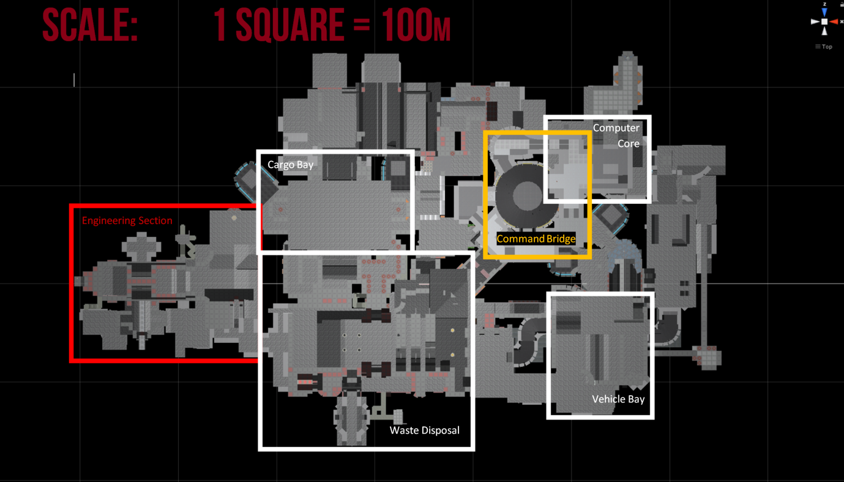

Profile orthographic View: 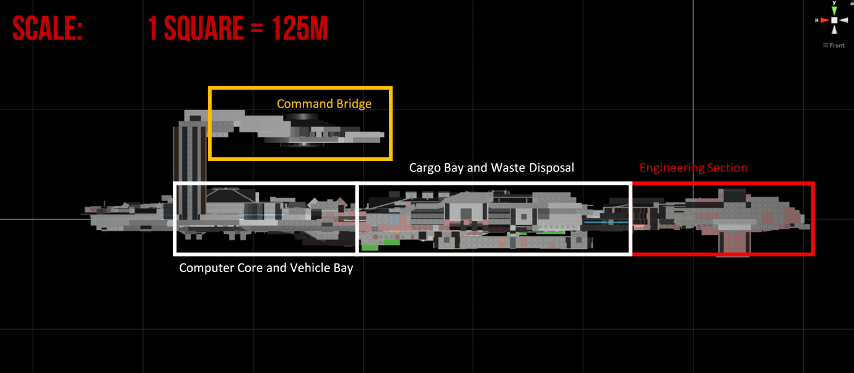

Areas not contained within boxes are transitional arenas and only open up on specific map combinations to bridge the gap between territories.

Changes to Level Design:

Throughout the process of designing levels, I found an incredibly insightful source to be the developer commentary released by Valve after the production of ‘Team Fortress 2’ **(Valve Corporation 2007).**

*The Original Plan Sketch*

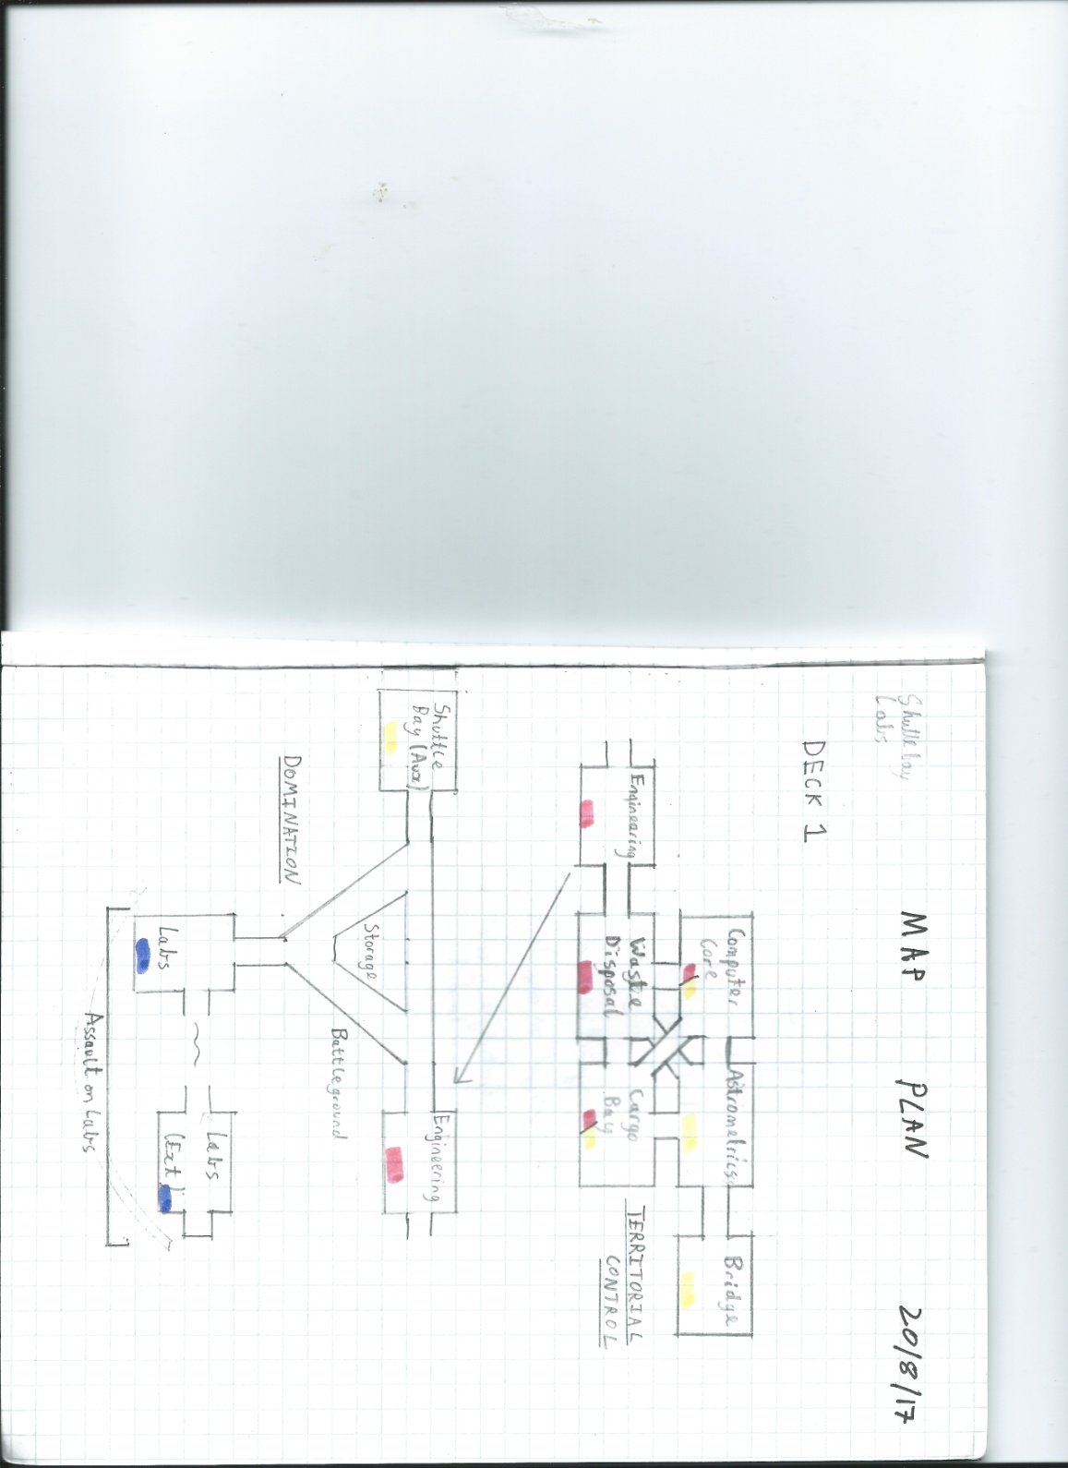

The original sketch differs from the released product in a number of ways. Most notably, the map depicted in the bottom half of the sketch never saw production, mostly due to the large amount of time required to create each territory to a suitable standard (roughly 1-2 weeks). Secondly, the Computer Core, Astrometrics, and Cargo bay all are either located in a different position or do not exist in the final version, this is mainly a cosmetic change.

Thirdly, it can be seen that some areas on the planned lower map are marked for a third blue team. Despite not being fully implemented, the code remains in the game for this team and the feature was not dropped until very late in development.

A revised and detailed plan was produced in the next week addressing two of the points above.

*The Revised Plan Sketch and Explanation:*

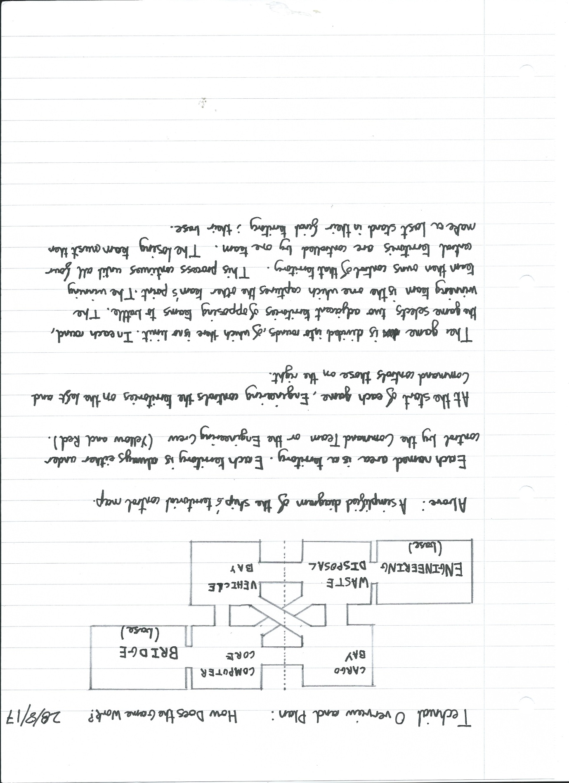

This revised plan saw little to no deviation during development.

The territory control concept was inspired by the unique gamemode from Team Fortress 2’s Hydro map **(Valve Corporation 2007a).**

**The Territories and Their Artistic Design:**

**Red Base – Engineering Section:**

The Engineering Territory was the first area to have been constructed. It was created in the summer of 2017. The map was tested soon after with a rudimentary build of the game, featuring no objectives and untested game play **(See testing report 1).**

*The Engineering Section before the Lighting had been baked to the scene:*

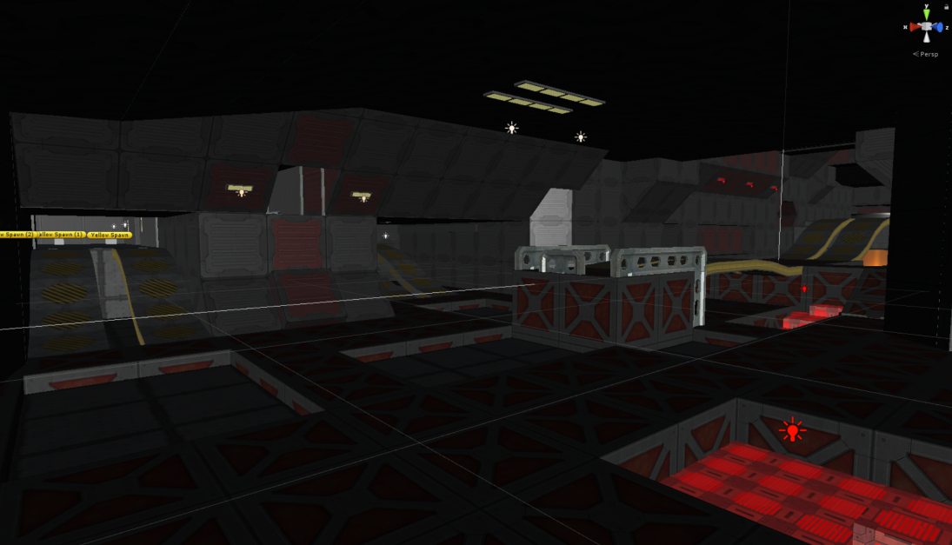

*The Engineering Section after the Lighting had been baked to the scene:*

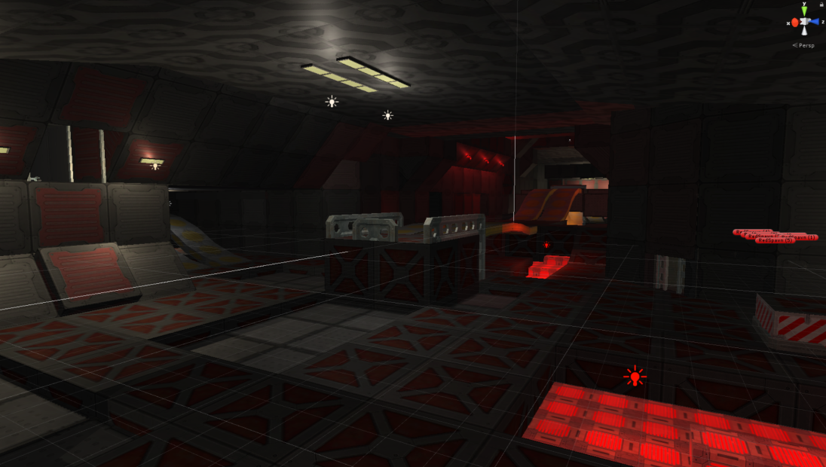

This territory adopts a warm colour palate, emphasised by red lighting around key areas such as the capture point; not only bringing these areas to attention but highlighting the fact that players are in the Red base. In addition, industrial textures as well as angular geometry were utilised to give the player the feeling that they truly are fighting in the bowels of the. This was a technique discussed by Ariel Diaz in Well’s developer commentary **(Valve Corporation 2007c, Ariel Diaz)** as well as in the ‘On Game Design’ blog **(Stout M, 2008, p2)**.

**Yellow Base – Command Bridge:**

Conversely to the Engineering section, the Command Bridge was the last territory to have been constructed.

*The Command Bridge while it was still under construction. As this was the last area to have been built, the other areas of the ship can be seen below it.*

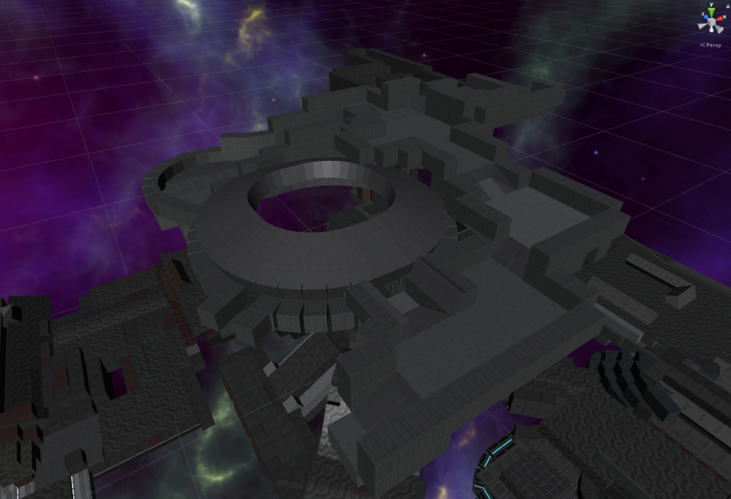

Smooth walls and round geometry were used extensively in the creation of the bridge, juxtaposing the industrial and angular design of the Engineering Section with a sleek and professional aesthetic – suggesting to the player that they are far away from Red’s Base and are at the final stage of the match.

*The interior of the Command Bridge while it was still under construction; the elevated focal point not only draws players’ attention, but fits in with the design.*

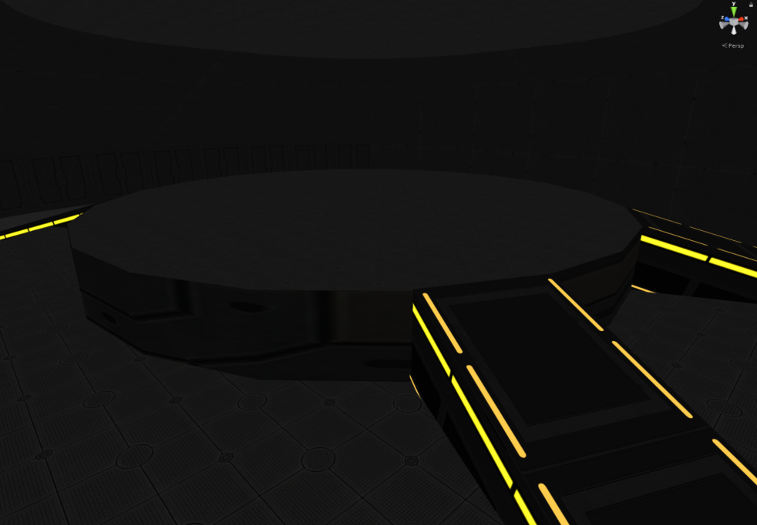

*The final capture point on the Command Bridge:*

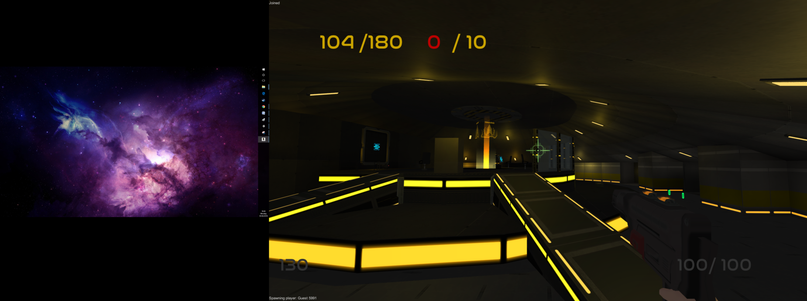

The low ceiling, yellow lighting, and clean textures all help differentiate this part of the ship from the rest.

**Neutral/Initially Red Territory – Waste Disposal**

The waste disposal territory was the second area created. Due to the position of the territory, it must be connected to four adjacent territories.

*Waste Disposal during its early stages of creation; entrances and exits to other territories have been marked.*

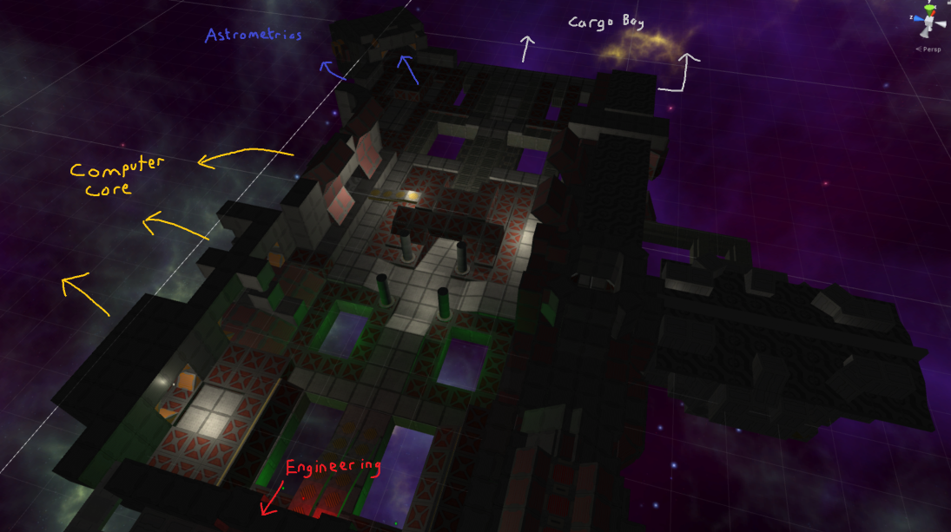

A floor plan of the territory has been created first; a technique which allows for the greatest amount of design freedom. It can be seen that the revised territory plan had not been created at this point because the old territory names and positions were used.

*The completed Waste Disposal Territory viewed through the eyes of CDR Boris:*

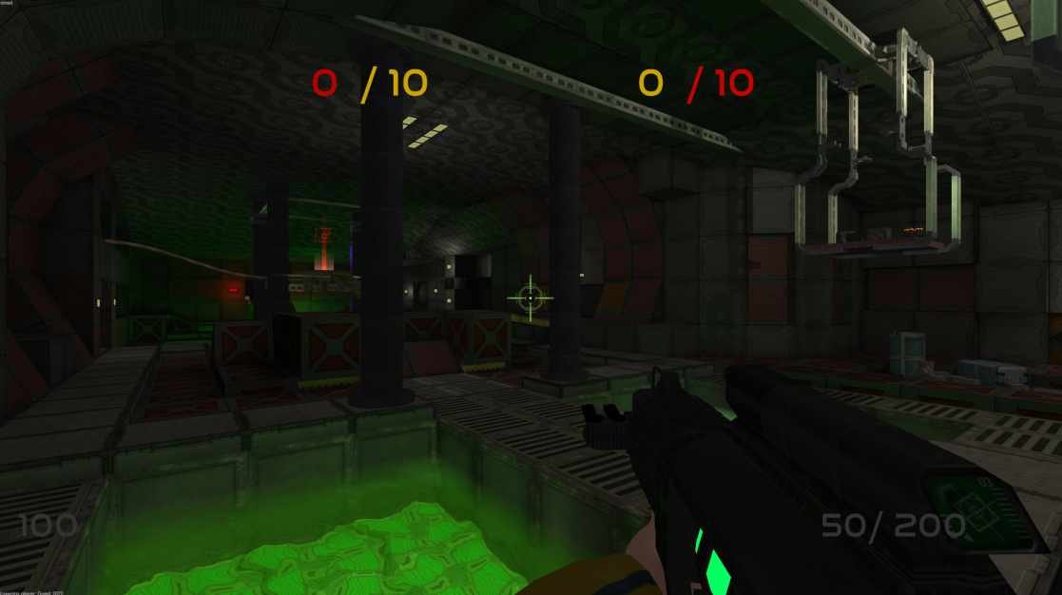

The completed Waste Disposal area features a similar aesthetic to the engineering section. It shares angular shapes and industrial textures, indicating that it is close in proximity to the Engineering Section. The territory is also always owned by Red team (Engineering) at the start of each game. Despite this, the use of neutral lighting reflects how control of the territory may change hands; a concept explored by Valve level designer Aaron Barber **(Valve Corporation 2007a, Aaron Barber).**

**Neutral/Initially Yellow Territory – Computer Core**

The Computer Core was the fourth territory created. In comparison to other territories (especially Waste Disposal), its layout is very open and features sparse cover. This encourages the use of long range weapons and fast characters such as Captain Dave.

*The Computer Core:*

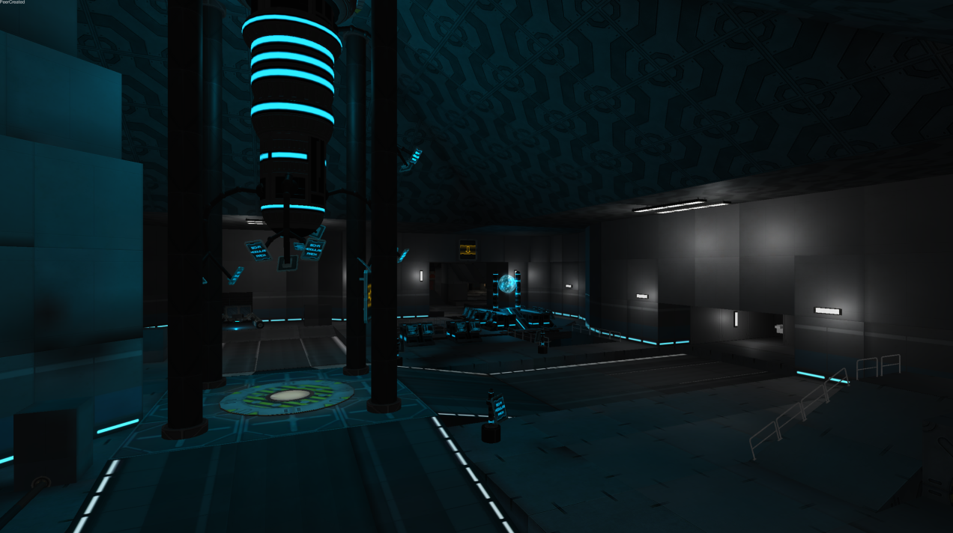

In this territory, the monolithic computer core brings the players’ attention to the capture point beneath it **(Stout M, 2008, p2)**. The territory uses the same selection of textures as used on the Command Bridge, indicating to the player that they are in an area of the ship which would most likely be populated with officers.

**Neutral Territory– Cargo Bay**

The Cargo Bay is a truly neutral territory. Its owners are randomly determined at the start of each game.

*The capture point room in the Cargo Bay:*

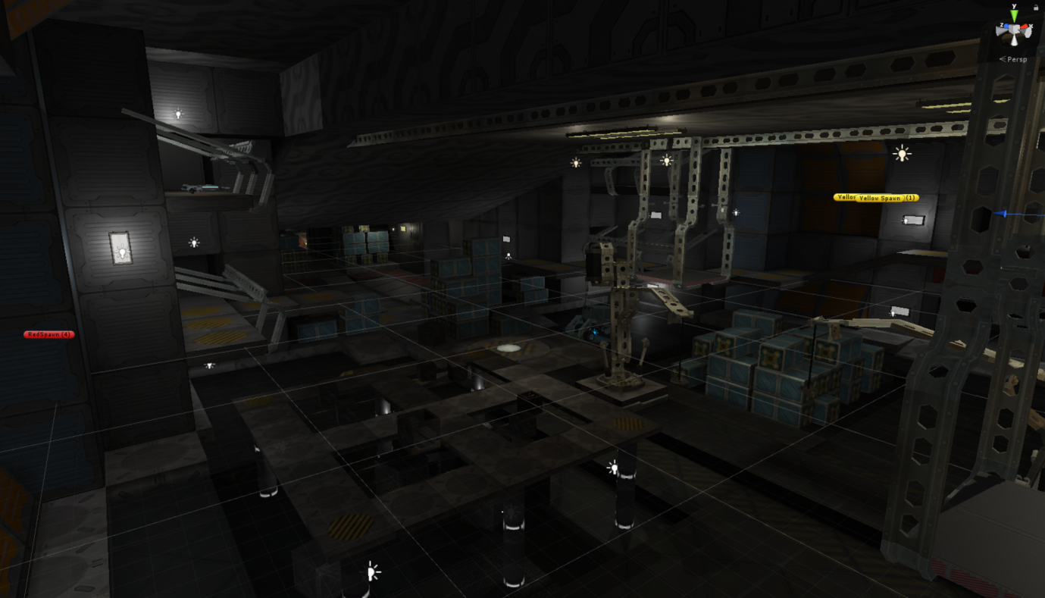

The territory features neutral lighting as well as a mixture of smooth and industrial textures; meaning that thematically the area could belong to either team.

Compared to other territories, especially the Computer Core, the Cargo Bay is a cluttered environment. This increases the frequency of close range encounters and the effectiveness of explosive weapons, favouring Commander Boris and Lieutenant Geddon.

The territory contains multiple height levels, allowing skilled players to traverse the area without ever touching the ground, granting and advantage and raising the skill ceiling of the game. **(Valve Corporation 2007b, Dave Riller).**

**Neutral Territory– Vehicle Bay**

The Vehicle Bay is a neutral territory. Its owners are randomly determined at the start of each game.

*The Vehicle Bay:*

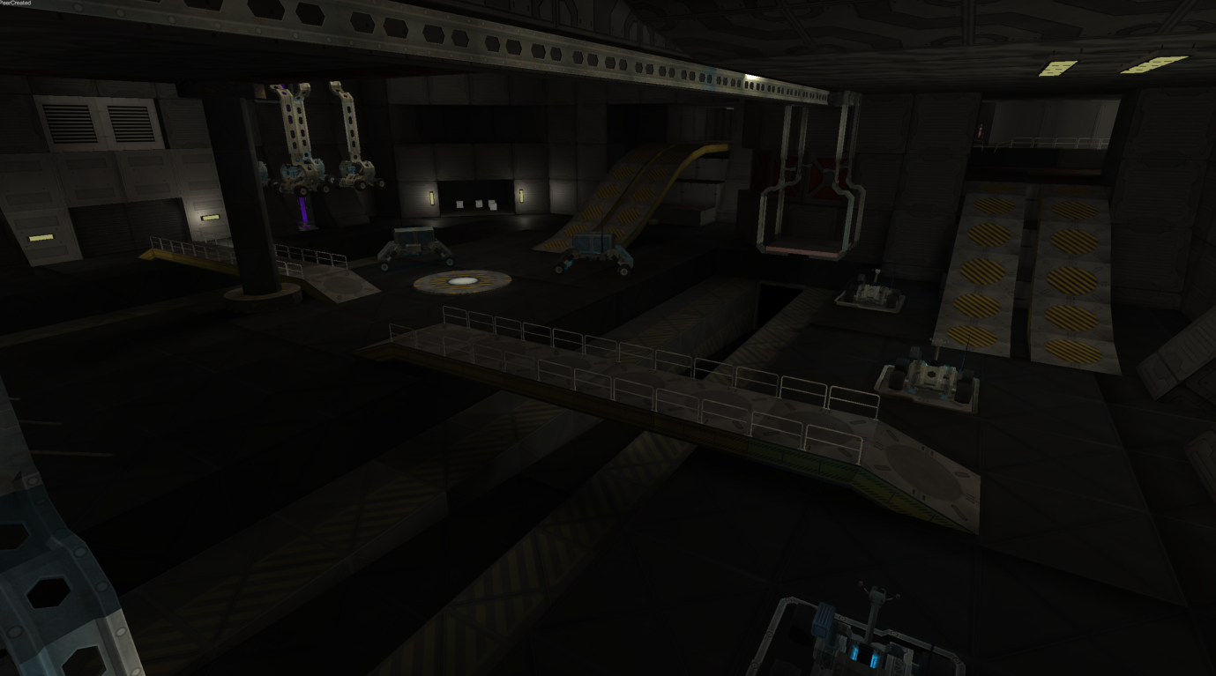

Much like the Cargo Bay, the Vehicle Bay features an array of neutral lighting effects as well as a grey colour scheme, emphasising the territory’s position.

Conversely to the Cargo Bay, this territory hosts a more open arena with clearly defined flank routes. This not only differentiates the area in terms of gameplay, but fits thematically with the idea that vehicles are held here and must be able to traverse the bay.

The Vehicle Bay was not planned to be constructed at its current location. A transitional arena between it and the Waste Disposal territory was originally planned to be created, however, I discovered that the resulting travel time to reach the opposing team’s point would be too great, especially since the distance between these two points is already one of the greatest in the game.

*A diagram of the distance between the Vehicle Bay and Waste Disposal:*

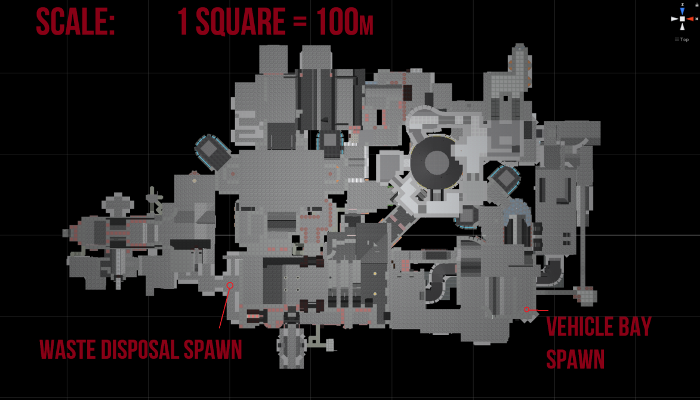

The distance between the spawns is already in excess of 350m. Any further length and the rest of the map would have to enlarge to compensate for this distance. See appendix **(Early Map Sketches: Waste Disposal – Transition Arena)** for the original plan.

*A before and after view of part of the arena’s conversion to territory:*

*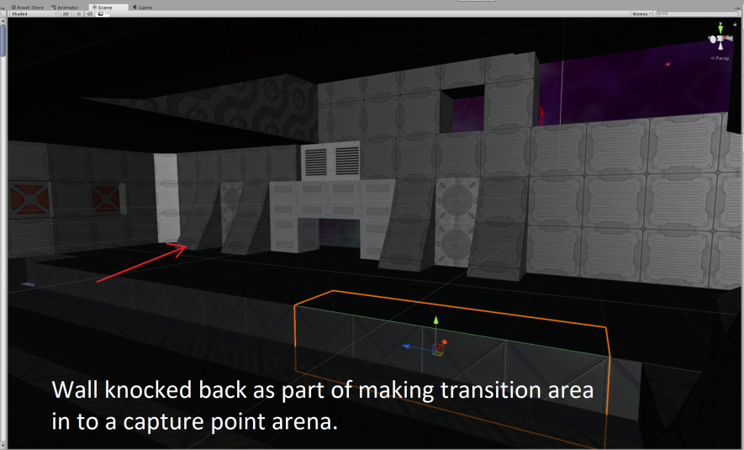Before: After:*

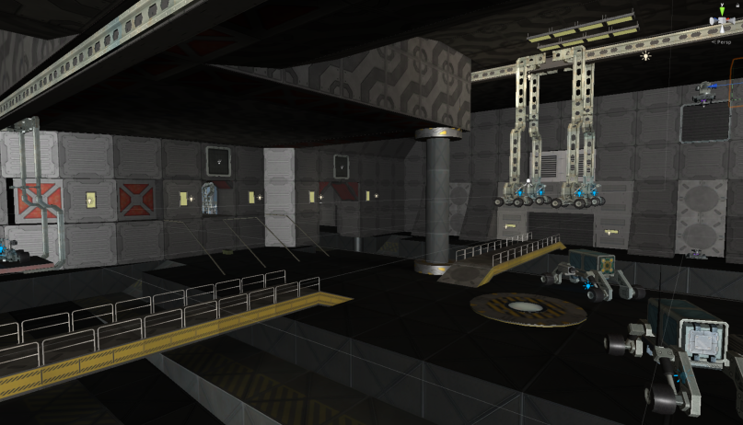

**Early Map Sketches:**

**Waste Disposal**

*A very early sketch for the Waste Disposal territory:* 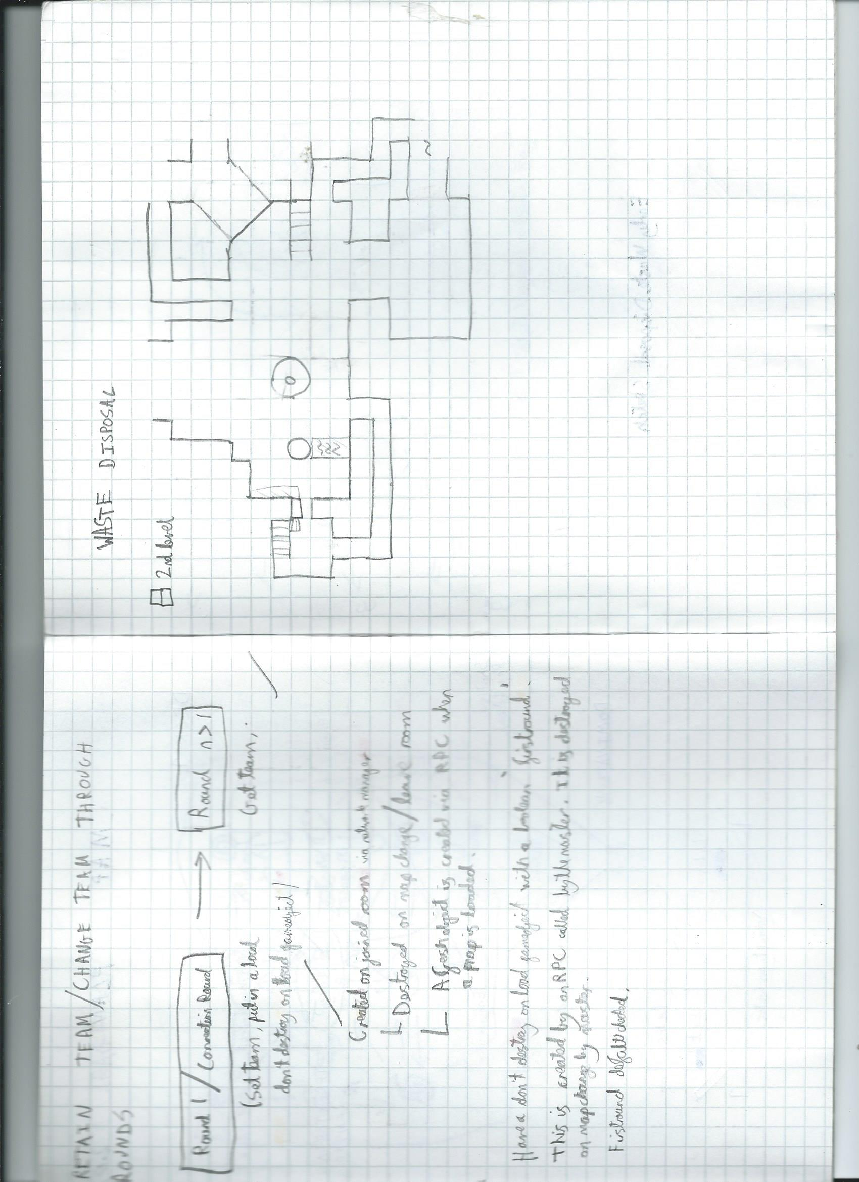

While some features of this sketch made it into the final version of the map (southern atrium, diagonal North-East path), recognisable characteristics of the area such as the toxic sludge pools and tunnel do not exist.

*A revised early sketch for the Waste Disposal territory:*

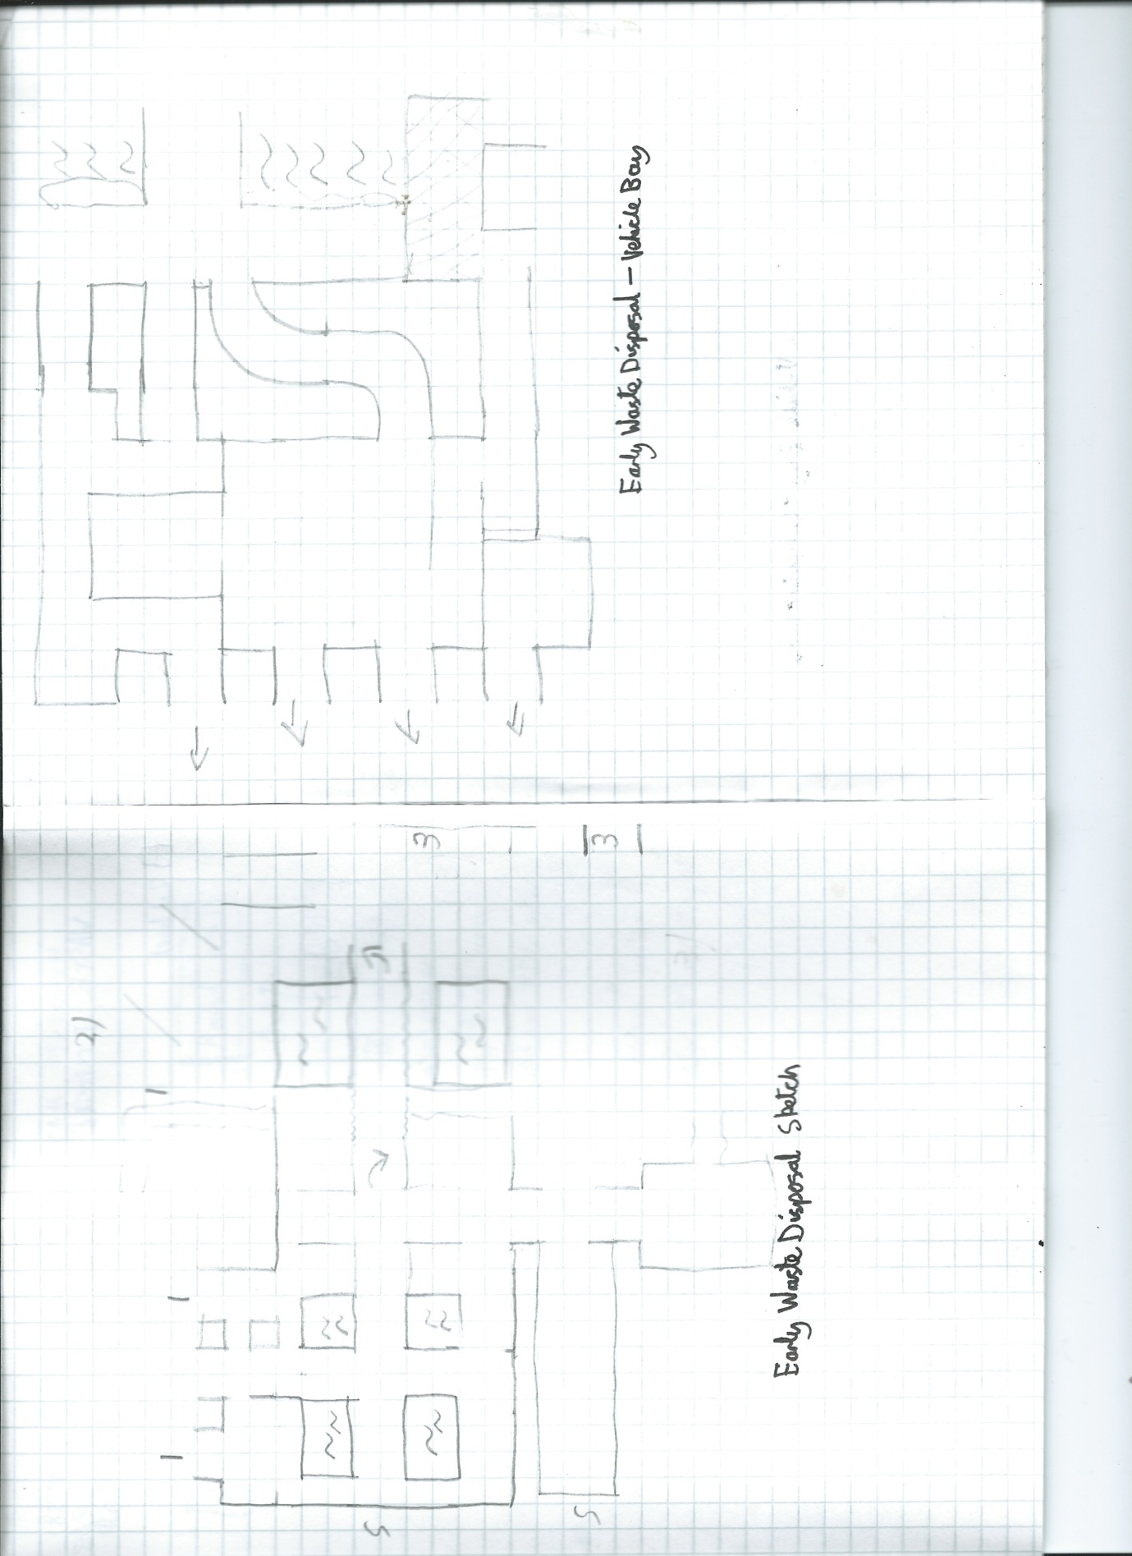

**Waste Disposal – Vehicle Bay Transition Arena**

*An early sketch for the Waste Disposal – Vehicle Bay transitional are:*

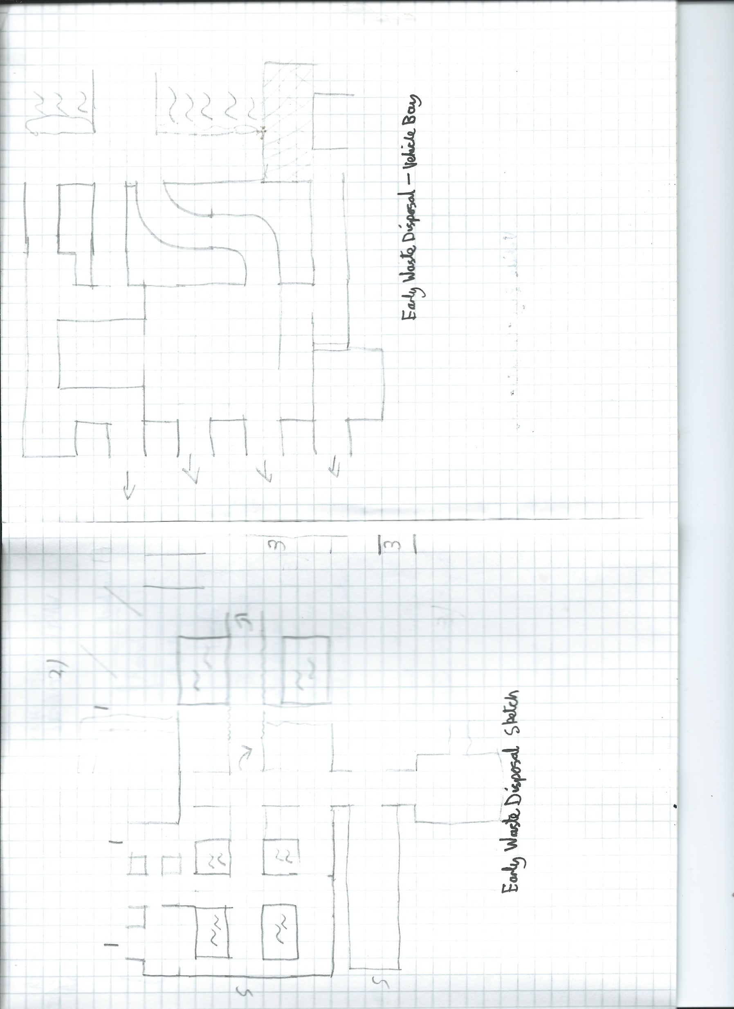

The final version deviated from this sketch plan. The Eastern area depicts additional sludge pools as well as an elevated overlooking platform. This area was originally to be mirrored in the vertical axis to create a symmetrical transition arena, however I deemed the distance between the opposing spawn rooms to be too great.

**Vehicle Bay – Computer Core Transition Arena**

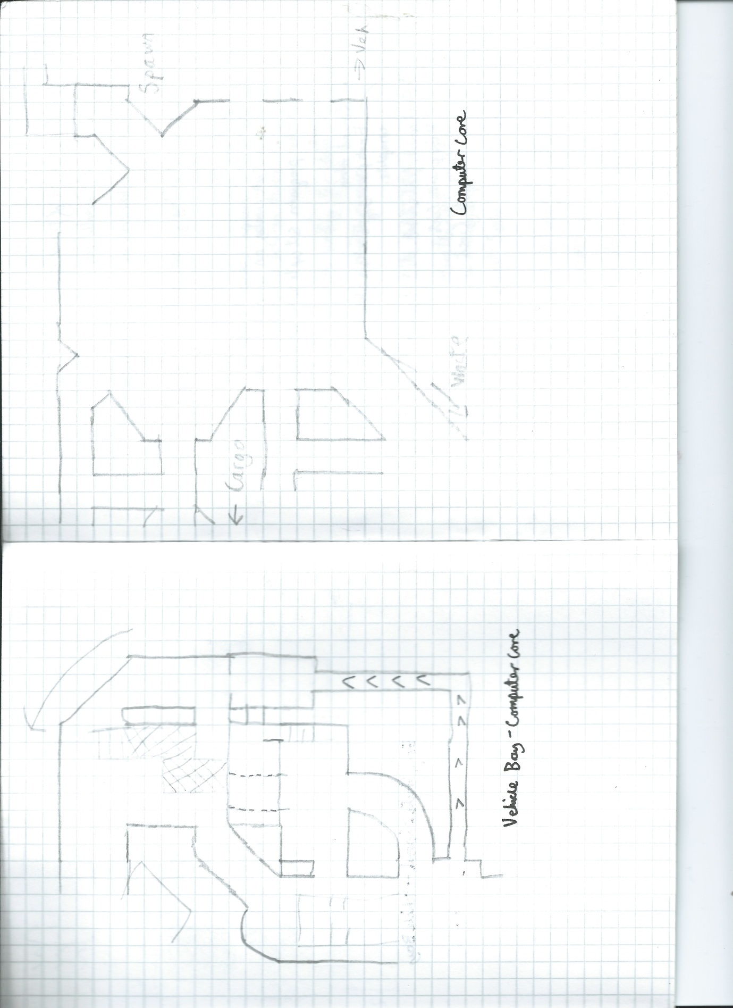

**Computer Core**



**Command Bridge**

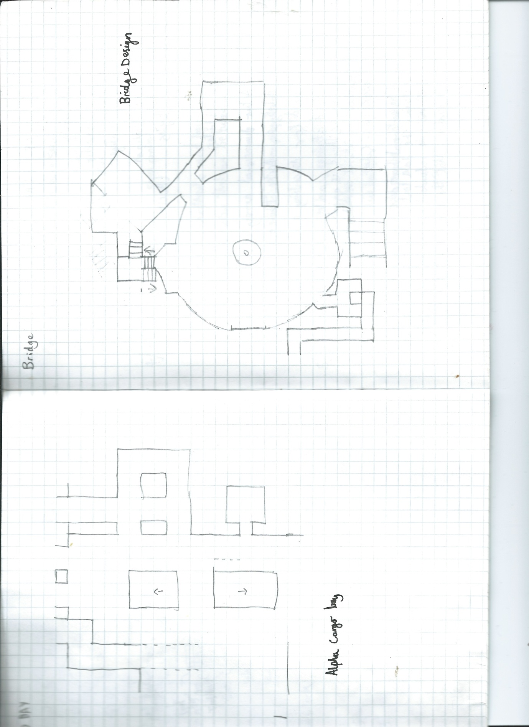

**Gameplay Level Design:**

Throughout the level design portion of development, I held one principle to heart: the 2 – 2.5 – 3 rule **(Stout M, 2008, p1)**. This rule states that fun and successful team based maps must have at least two or three paths to the objective. The 2.5 refers to a third alternate route which presents a detriment to the player (eg increased risk of damage or much longer route). This rule helps prevent bottlenecks and keeps gameplay interesting.

**Case Study of the 2.5 rule:**

An example of this rule is the transitional arena between the Computer Core and Cargo bay. I took some inspiration from the area connecting the Dam and Warehouse from TF2’s Hydro **(Valve Corporation, 2007d).**

*A top down view of an area from TC_Hydro:* 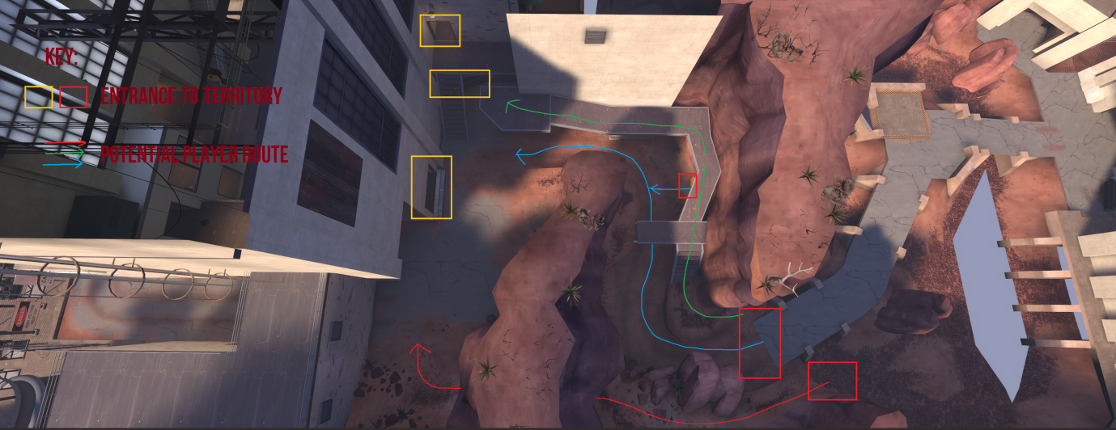

It can be seen that there are three potential routes players can take to traverse this area. In this case, the route which warrants the ‘2.5’ status is the lowered blue path. A risk/reward situation is created by placement of items on this path, but the height disadvantage discourages its use **(Stout M, 2008, p1)**. I wanted to incorporate a similar design element in Space Quest 2099.

*A top down view of part of the transitional arena between the Cargo Bay and Computer Core:*

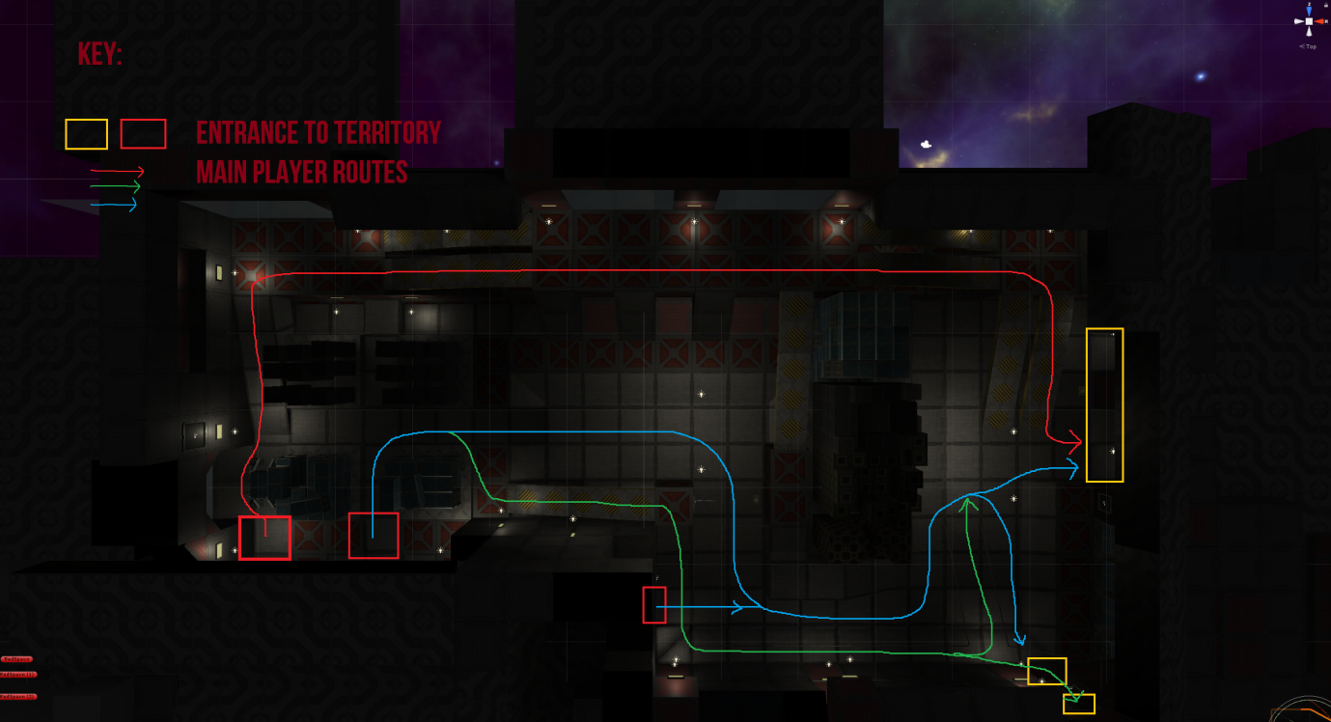

There are three main routes that players can take in this area, although they are not fixed in place and players may easily change path. Once again, the blue pathway is potentially the most dangerous due to its height disadvantage to both the red and green routes. Despite this, there is health pickup and an array of ammunition on the ground, enforcing the risk aspect.

When designing this area, it also occurred to me that I could also design each pathway to be advantageous to a particular character.

*Another top down view of the transitional arena, the most effective paths for each character are shown:*

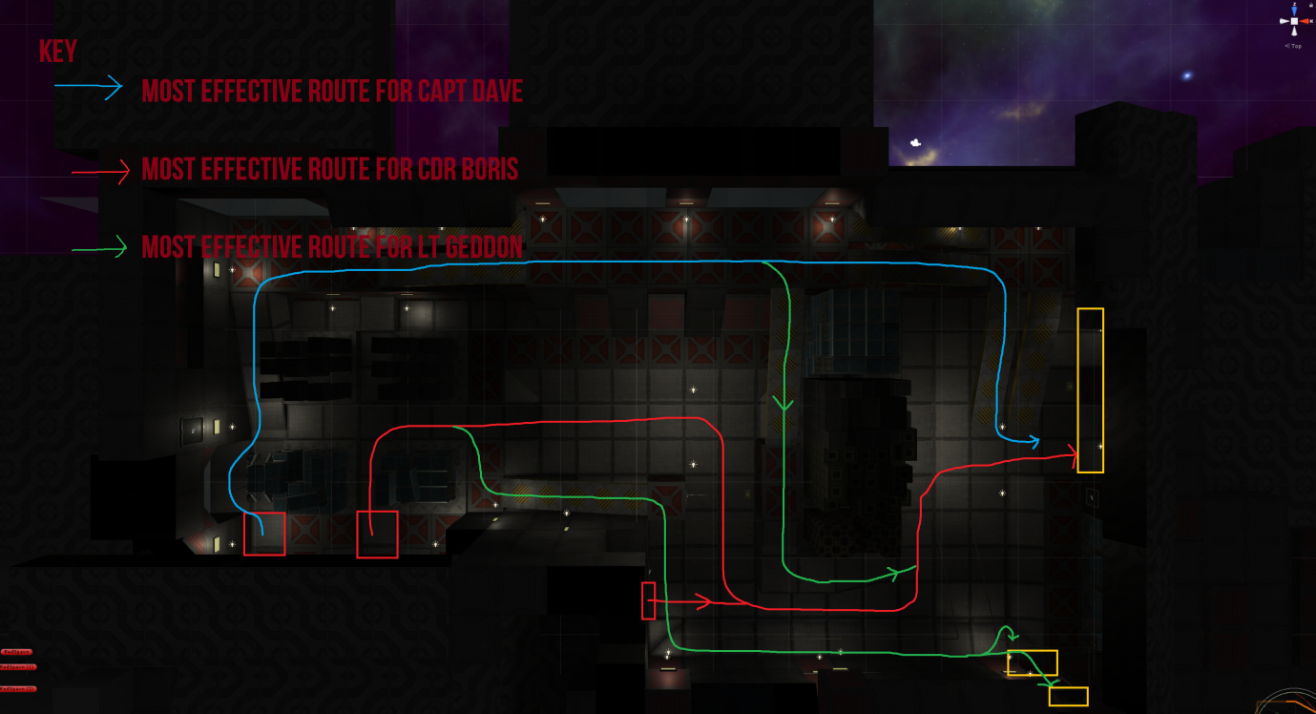

The long and open sightline presented by the blue pathway heavily favours Capt Dave, the character armed with a long range beam rifle, as it provides the player with the ability to efficiently pick off opponents using the same route in the opposite direction. The high vantage point also provides protection from Boris’ and Geddon’s explosive attacks **(Stout M, 2008, p1).** This route’s advantages are offset by the lack of pickups.

The Red Route, although potentially the most dangerous, favours CDR Boris primarily for two reasons:

* Boris has significantly more hitpoints than the other characters. As a result, he is able to survive powered beam rifle shots and explosive attacks, enabling him to make full use of the health packs to replenish his hitpoints.
* Boris has the strongest close range damage of any character. He can use the sharp, blind corners to his advantage by surprising enemies up close.

The Green Routes favour Lt Geddon. Due to their elevated position, he is able to make full use of the rocket launcher’s explosive damage, while not being so high to lose accuracy.

This much attention was paid to each area of the map, this is only one area of many.

**Character Animations:**

**Setup:**

Character models were created using Adobe Fuse **(Adobe 2017a)**, a powerful humanoid character design suite. After characters were modelled, they were exported to Mixamo **(Adobe 2017)**; another Adobe service which automatically creates the underlying animation skeleton for the character.

Despite being a simple to use piece of software, the service charged large amounts for their pre-made animations. Since I was not prepared to spend upwards of £50 for character animations, I endeavoured to find an alternate source.

Some studios, such as cMonkeys, publically release their raw motion capture data on the internet **(Unity Technologies, 2012)(cMonkeys 2012)**. Consequently, I was able to download and extract some suitable template animations. These animations required extensive work to be made game-ready:

Each animation clip (walking and idle) extracted from the raw data had to be cropped to create a looping animation clip with approximately equal start and end frames. It can be seen in the screenshot below that the original 126s of animation data was cropped to just over 2 seconds of length.

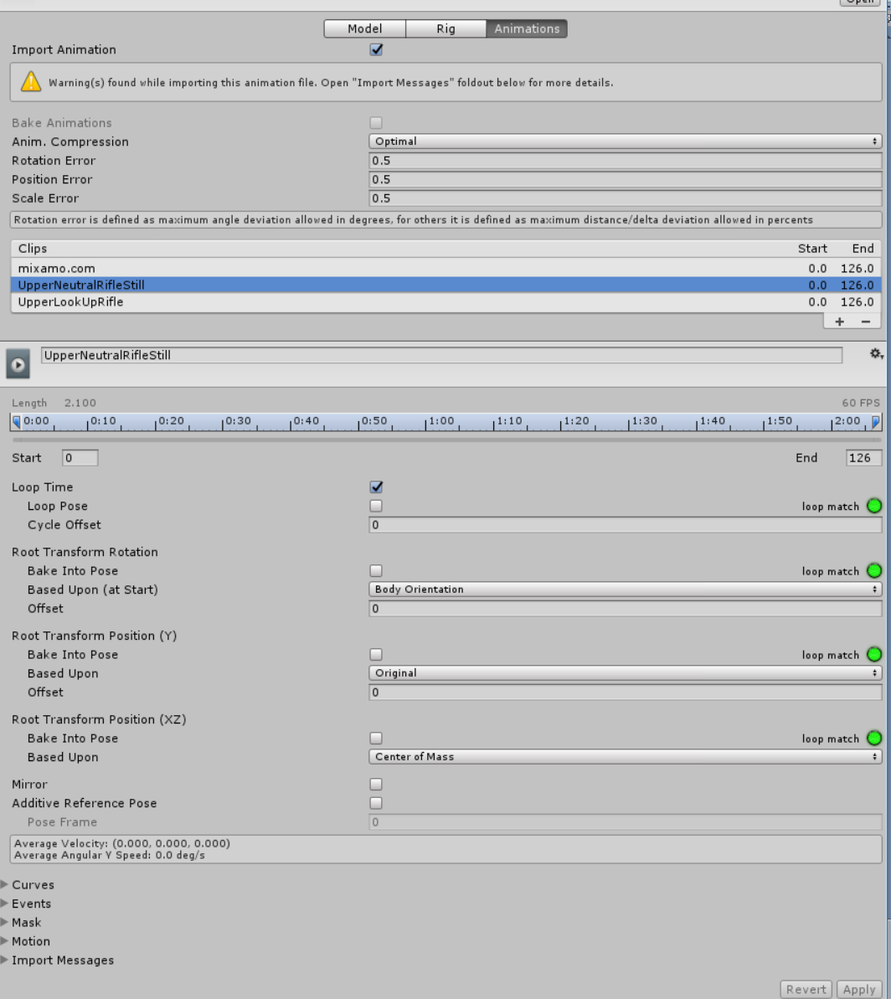

**Animation Masks:**

I wanted the torso of each character to behave independently from the legs as this would allow for a looking motion in the vertical axis. As a result, a separate set of animations had to be made for each half of the body. To accomplish this, I researched the features of Unity’s Mechanim Animation System **(Unity Technologies, 2017a)**

Through the use of a technique called ‘Masking’, I was able to create two independent animation systems. This makes an animation only apply to specified skeletal animation bones.

*The upper body animation mask manages character model looking and firing animations:*

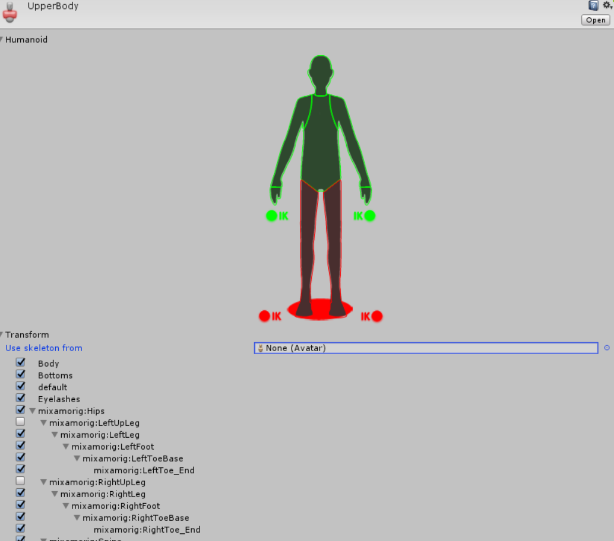

*The lower body animation mask manages walking and idle animations:*

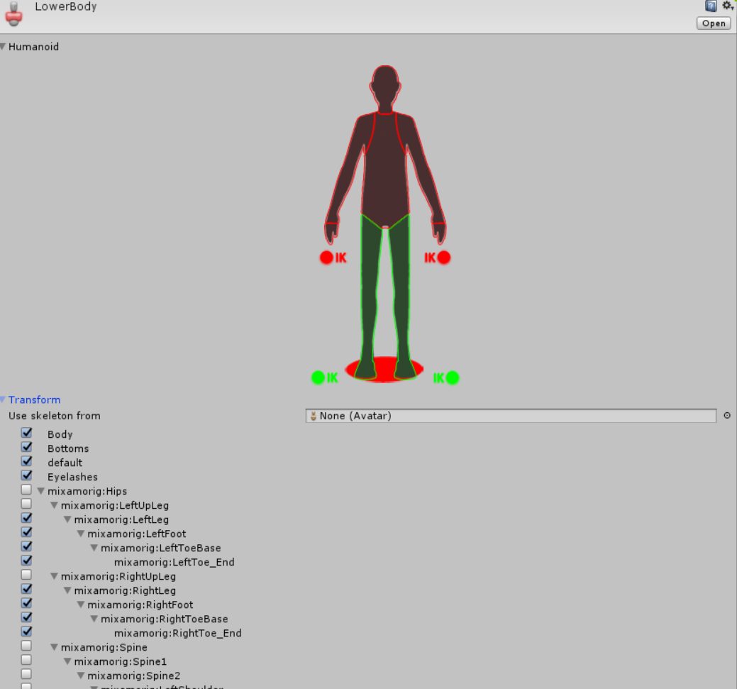

Animations are controlled via the use of a custom state machine **(Unity Technologies, 2017c)**. Parameters are defined to all players in the game and the machine plays the appropriate animation. Each character has two state machines; one for each mask.

**Upper Body State Machine:**

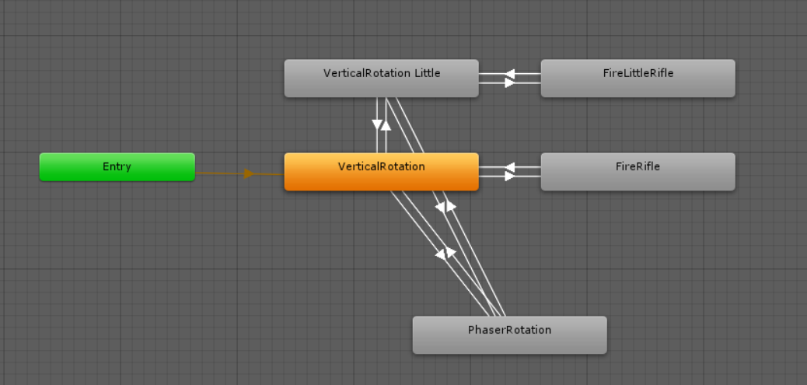

Each of the rectangular nodes is as a subroutine blend tree (**Unity Technologies, 2017d)**; allowing the interpolation of multiple animations. For example; the PhaserRotation tree interpolates the result of an animation between three states along a single axis based on the player’s looking angle:

*The PhaserRotation blend tree transcribes the player’s current looking angle to animation.*

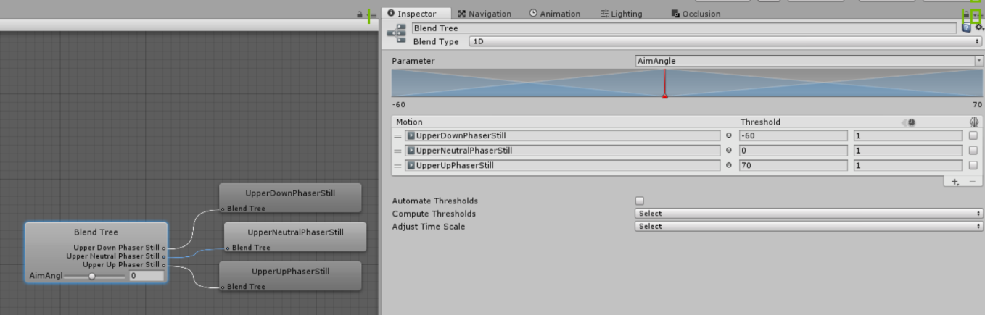

*A representation of each animation state in the game world:*

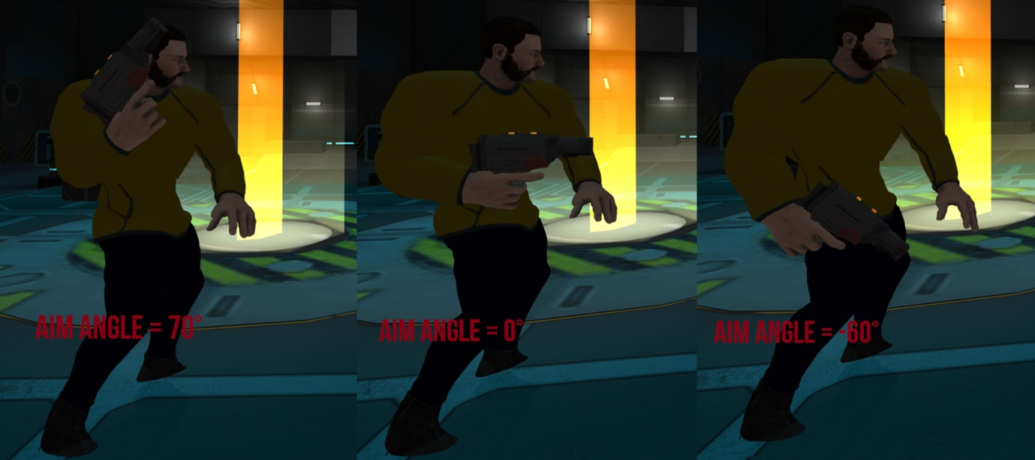

By using this technique, an animation state of any angle between 70° and -60° can be generated, despite only having 3 reference animation states:

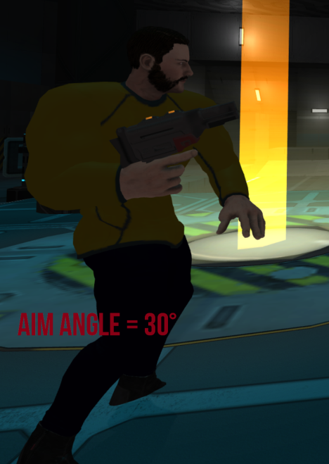

Each of the 1-dimensional blend trees for other weapons function on this principle, although Capt Dave required his own set of animations due to his small animation skeleton.

**Euler Angles:**

Space Quest 2099 utilises Euler angles for a variety of purposes, including accessing the rotation of a rigid body. Despite the fact that rotations are set and altered using the Quaternion method, I chose to read the rotation of rigid bodies with Euler angles. Whilst the camera is not technically a rigid body since it does not respond to forces, its rotational identity can be modelled as such.

Euler angles have a relatively simple representation: three angle values for X, Y and Z that are applied sequentially. To apply an Euler rotation to a particular object, each rotation value is applied in turn as a rotation around its corresponding axis **(John Baker, M, 2017)**. The Unity Engine allows me to read the rotation of the player’s view camera using Euler angles (**Unity Technologies, 2017e)**. Therefore the aim angle is simply determined by:

* reading the Y angle if 0 < y < 90
* -(270 – y) if 270 < y < 360

This angle is then transmitted on change using the **Network Character** script to other players.

**Lower Body State Machine:**

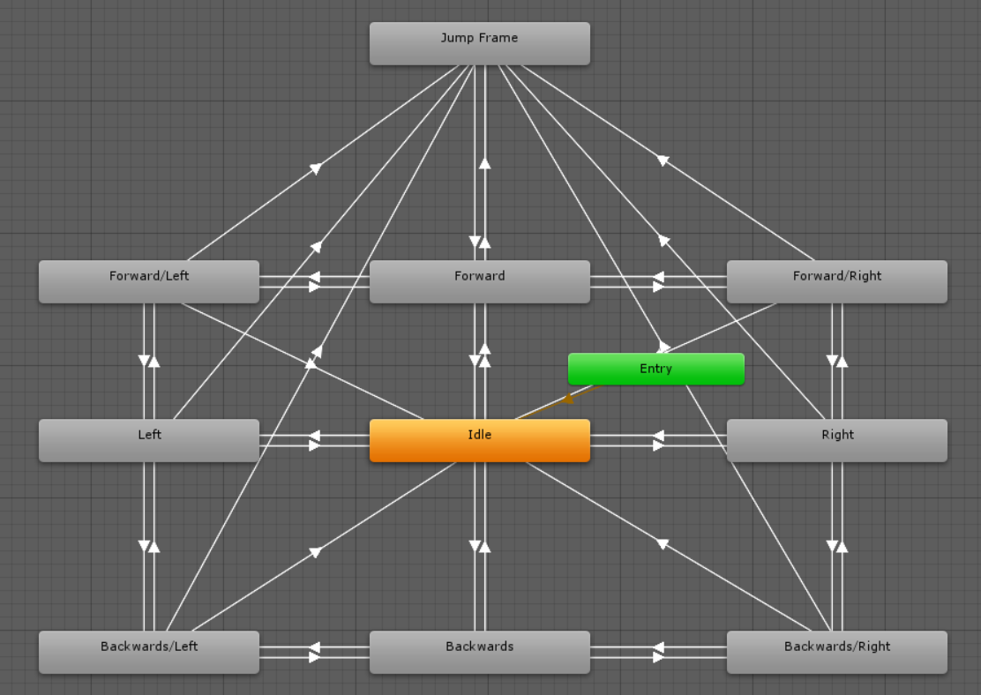

The lower body state machine is more complex. It controls the motion a character’s legs based on the value of two variables: Relative Horizontal Movement and Relative Forward Movement.

As a result, 2-dimensional Cartesian blend trees are required for diagonal strafing animations:

*The Forward/Left blend tree is represented by a co-ordinate grid. The red dot is the current relative weight of the forward and left animations.*

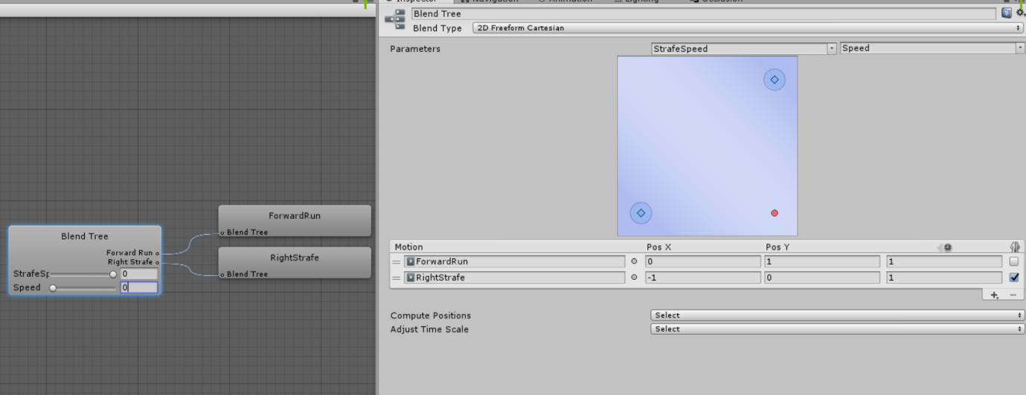

The Jump Frame acts as an interrupt; immediately forcing the jump animation to play when visited.

**The Characters:**

**Captain Dave:**

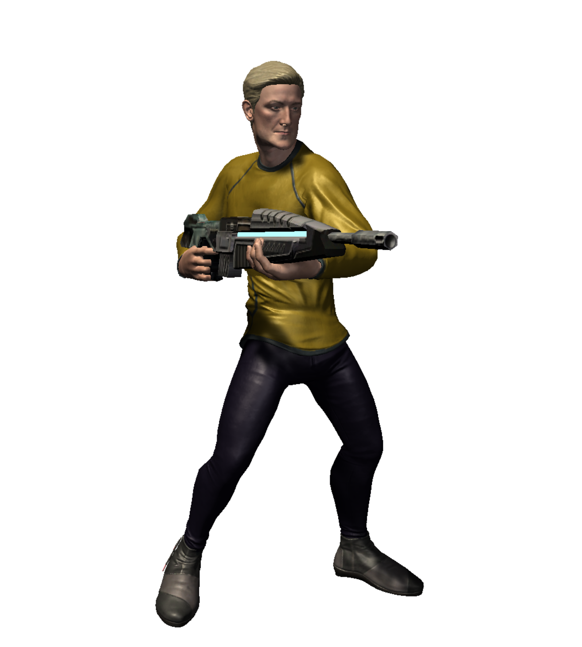

Captain Dave has the greatest movement speed of all characters, but also the least health.

His weapons include:

* Particle Beam Rifle
* E12 Blaster Rifle
* Side Phaser

He is the most deadly at long range, but can be taken out by a single charged beam rifle shot.

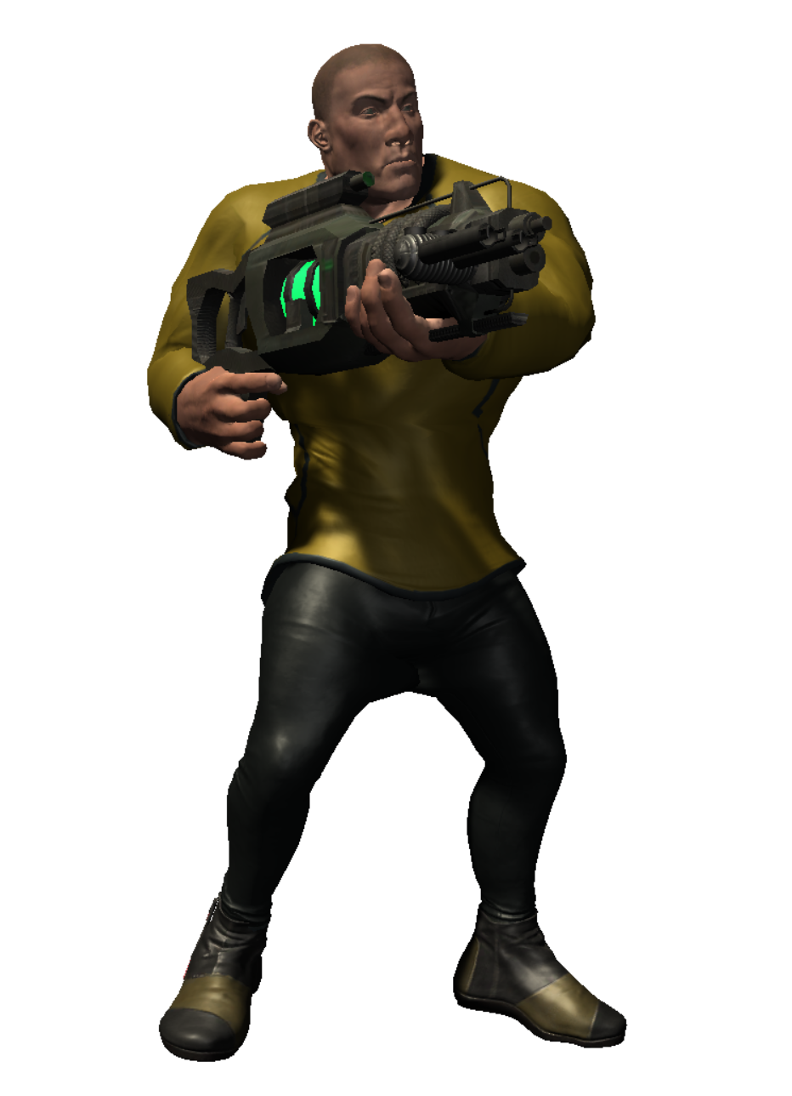**Commander Boris:**

Commander Boris has the lowest movement speed of all characters, but the most health. His playstyle and armaments is opposite that of Dave.

His weapons include:

* Heavy Tetryon Gattling Array
* Repeating Plasma Compression Gun
* Side Phaser

He is the most deadly at short – mid range but his slow movement speed and large stature makes him an easy target.

**Lieutenant Geddon:**

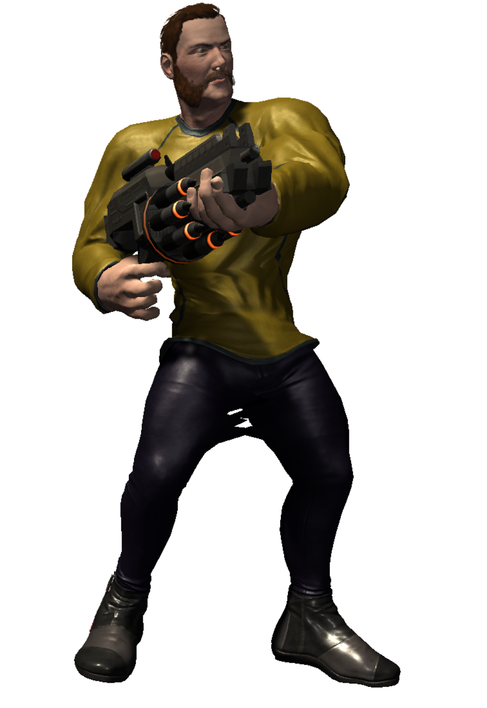

Geddon occupies somewhat of a middle ground between the other two characters. He has average health and movement speed, but can have the highest mobility in the hands of a skilled player due to explosive jumping **(Id Software 1996).**

His weapons include:

* Experimental Rocket Rifle
* E12 Blaster Rifle
* Side Phaser

**Linear Interpolation Coroutine:** 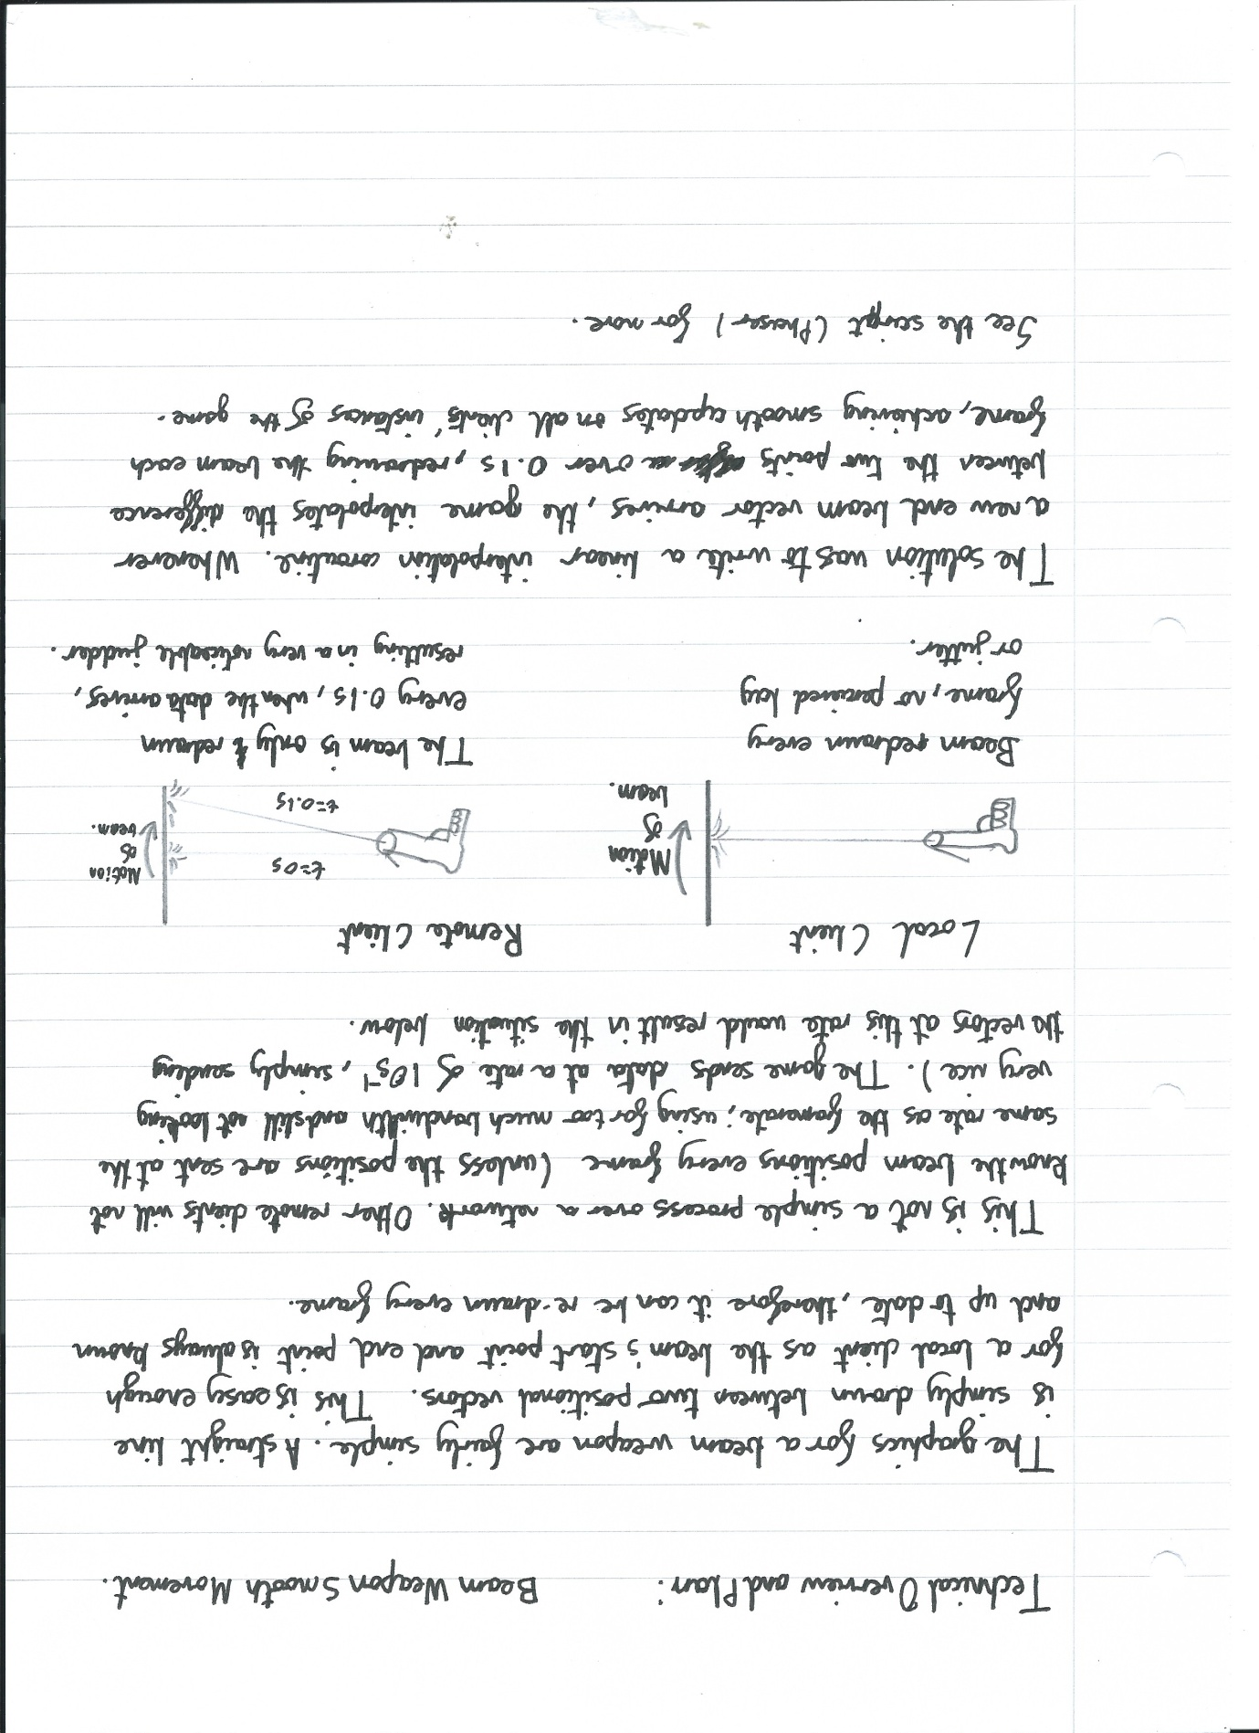

**Bullet Spread and Projectile Deviation:**

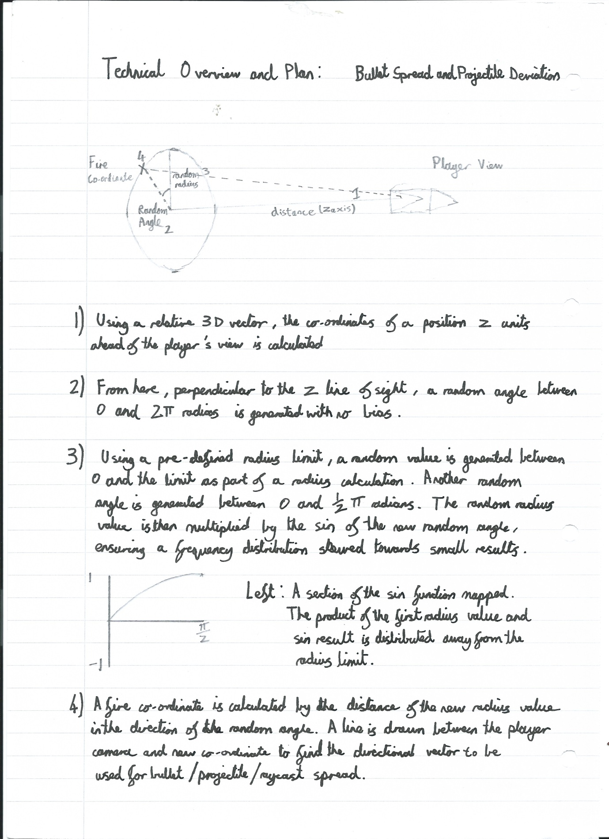

**Multiplayer Testing Reports:**

Test 0:

Test zero took place in the week of 13/8/17. The test’s purpose was to establish a connection across the internet to a remote client and ensure character vector transformation and interpolation function correctly. There was no gameplay at this time, but the test was a success.

Test 1:

Test one took place in the week of 18/8/17. At this point, four (as yet unnamed) weapons had been implemented:

* Raycast Rifle
* Single Shot Projectile Launcher
* Explosive Rocket Launcher
* Continuous beam weapon

In addition, three characters had been added, but differing very slightly in health and movement speed.

* Captain Dave
* Commander Boris
* Lieutenant Geddon

During this test, there were no game objectives or score tracking. The test’s purpose was to gauge the currently unproven gameplay. Five players participated and provided the following items of feedback:

* Players move too fast and are too hard to hit.
* Weapons did not deal enough damage; it took too many hits to defeat a player.

This feedback has since been acted upon. Players have a decreased speed and all weapons have an increased damage.

Only a single map was tested at this point.

This test was recorded:

https://www.youtube.com/watch?v=IZGW_ioh-iY&t=230s

Test 2:

Test zero took place in the week of 24/11/17. At this point, the entire ship’s interior had been created and joined to create the territorial control gamemode. This test’s purpose was to test everything from performance to gameplay.

The following weapons were in play:

* Raycast Rifle - Rifle
* Rapid Fire Projectile and Energy Grenade Launcher – Hellwailer (codenamed)
* Explosive Rocket Launcher – Rocket Rifle
* Continuous beam weapon - Phaser
* Moderate to High rate of fire projectile launcher - Blaster rifle

The following characters were in play:

* Captain Dave
* Commander Boris
* Lieutenant Geddon

Four participants provided the following feedback:

* Performance issues were very prevalent. Single figure framerates on low-end computers.
* The scoreboard would occasionally not update player statistics.
* Sometimes opening the pause menu crashes game.
* The attack/defence timer does not update for all clients on the final stage.
* In some areas, standing on a capture point updates the wrong counter on the user HUD.
* The Rapid Fire Projectile Launcher’s secondary fire can collide with the shooter on the receiving client’s end.
* The blaster rifle still fires when the menu is open.
* Occasional host crashes when changing areas after a round.
* It is easy to not know where your objective is on a dynamic map; players became lost.

The following actions were taken to rectify these issues:

* Occlusion culling was applied to each map to aid performance issues. The game now only renders what the player can see. Significant performance increase.
* The scoreboard script was edited.
* It turns out that the pause menu wasn’t crashing the game, but the escape key was bound to quit the game in another script. This issue will be rectified if I can locate the script.
* On the host client’s instance of the game, the attack/defence timer passes its current value to all other players in the room every 5 seconds. This ensures the timer shows a correct value.
* Capture points now update the correct GUI element.
* A modification to all projectile weapon scripts was made. Projectiles now are set to ignore collisions with the shooter.
* The blaster rifle script now makes a check with the ‘can shoot’ script to ensure that it cannot fire when the pause menu is open.
* Dynamic objective markers have now been added to direct players to their destination.
* The host crashes on round change may have been resolved. This issue was caused by a fault in the algorithm used to randomly select areas to battle each other. Originally, the game would randomly select a territory then make comparisons to adjacent territories. If there were no valid adjacent territories, the script would cause the game to be stuck in an infinite loop. The script was amended to only allow a finite number of comparisons before recursively calling itself with a different territory to compare. More testing is needed to validate this solution.

Test 3:

Test 3 took place on the subsequent day to test 2. It contained all of the features and settings included in Test 2, but with the aforementioned bug fixes.

The following feedback was provided:

* The phaser deals too much damage.
* Menu options do not display in very low resolutions.
* Weapon scroll icons on the HUD would aid player confusion.
* Character images on the character select menu do not represent the team colour.
* The hellwailer’s alternate fire is a 2d sound on client instances of the game.
* Weapon sound effects are too loud.

The following actions were taken to rectify these issues:

* Phaser damage reduced
* The size was increased. This somehow fixed the low resolution menu problem.
* Hellwailer alternate fire now has a logarithmic amplitude falloff.
* Weapon sound effects volume decreased.

**Progress Log:**

|  |  |  |  |  |
| --- | --- | --- | --- | --- |
| **Week** | **Activity (what you have done)** | **Outcomes (any problems or successes)** | **Follow up (what you will do next)** | **Notes** |
| **20/6/17** | Research of potential network architectures as well as server hosting. | A client-server network architecture will be utilised through the use of Photon Unity Networking. | Set up network and attempt to achieve simple vector transformations. | **-** |
| **29/6/17** | Smooth motion achieved over a network - player avatars move smoothly and can only be controlled by their owner. | Player avatar transformations appeared choppy at first. Positions are now interpolated between network updates.  Players can now move their avatar and receive the positions of other players where upon motion is smoothly displayed. | Create a humanoid character and rig it with animations. Explore methods of animation control and attempt to synchronise over a network. | Due to the send rate causing characters to update their positions in a choppy manner, I wrote a linear interpolation coroutine. |
| 5/7/17 | A humanoid character has been simply animated using data from a mocap archive, only animations in four directions. The animation parameters are transferred to all other players on the network. | Despite the character being easy to create, separating the leg motion from the torso motion so that characters can hold objects has proven difficult. Therefore only a single animation is used for the entire body at this point. | Separate leg and torso animations. Add an animation parameter that allows for the implementation of vertically variable torso animations. | The aimed date for Simple Raycast Weapons, Hitpoints, and Respawning may be missed.  This should not be a problem as a very large chunk of time has been allocated over the Summer Holiday for level design so other deadlines can eat into this if necessary. |
| **13/7/17** | The humanoid character has now been animated such that the torso moves based on the y rotation of the player’s looking angle. The character is able to hold a rifle shaped object. | This was a time consuming process. It was necessary to manually create animation frames by editing the rotation of various joints. A time consuming process that had to be completed three times to provide a reference for the up, down, and neutral angle. | Simple raycast weapons will be created (weapons functioning with an immediate impact and no travel time). If possible, a character animation should be created for when the weapon is fired.  This weapon should interact with a hitpoint script on other players. Players should respawn if their hitpoints reach below zero. | It appears as if a new set of animations will be required for characters with different body sizes. This is problematic as it would massively increase the required amount of work, therefore, only a few body sizes and proportions will be used. |
| **20/7/17** | Raycast weapons have been implemented as well as the aforementioned related features. | Basic functionality has been achieved. Program tested with another player. | Although it has not been mentioned in the plan, teams will be implemented. This would also include the ability for members of the same team to be impervious to each others fire.  Projectile weapons will be implemented if there is enough time. |  |
| **27/7/17** | Teams and projectile weapons have been implemented. | In addition to straight line beams, projectiles may now be fired by players from a second weapon. Beams and projectiles only damage players of a team other than the shooter’s. | Explosive physics should be implemented in the coming week. This should apply force inversely proportional to the square of distance from the centre of the explosion.  Damage should also be dealt according to this rule. | Projectile weapon hit detection functions client-side. Any multiplayer game will have some discrepancies between game instances, therefore collision detection goes on the principle of:  “If you shoot and it hits on your end, then it hits”. |
| **4/8/17** | Explosive physics have been implemented. | From a third weapon, the player may now fire projectiles similar to that of before, with the difference of an explosion on impact with any surface. | Taking a break from the more technical areas of development, the first playable map should be created. This may take between 1-2 weeks depending on the amount of detail.  Fitting in with the game’s theme, the map should be an area of the ship. This map will be the engineering section. | Explosives obey friendly fire rules. |
| **11/8/17** | A significant proportion of the engineering section map has been completed. | An eye for detail significantly increases the time taken to create an environment. Currently the map is perfectly functional, but detailing should be completed prior to the first play test. | I feel as if the game requires a fourth unique weapon before the first play test.  I plan to implement a continuous beam weapon, akin to a *Star Trek* phaser. |  |
| **18/8/17** | The map has been completed and is ready for play testing. A heavy workload ensued when trying to implement the beam weapon. Despite this, it has been successfully implemented. | The beam weapon proved challenging to create when programming how it behaves on other players’ instances of the game. This was because the beam would appear to judder between network updates as its start and end position were updated. This problem was solved by writing and calling a linear interpolation coroutine between network updates on clients’ instances, interpolating the position of the 3 dimensional hit vector between two points over a known time. | Next week should see a play test with multiple players. After this, plans should be formed about the ‘Masterplan’ to join up all the maps. | The interpolation coroutine was created as a compromise between network traffic and in-game graphics. It appears to work very well. |
| **25/8/17** | Playtest carried out. Planning of overall map ‘Masterplan’ has commenced, new map area is now under construction. | Playtest feedback:  -Players move too fast/too hard to hit. Therefore players have had their maximum speed decreased.  -Weapons did not deal enough damage. Weapon damage has increased.  See “Test 1” in the testing report log. | The coming weeks will be set aside for level design.  Presently, the Waste Disposal area is under construction. | What is the Masterplan?  This plan is to create six distinct maps or ‘territories’, four of which are connected to at least three other territories. The objective is to take over the entire map by capturing 'territories'. One territory on each end of the map represents one of the team's bases; the others are split equally between the teams. Each round in a match consists of a territory-versus-territory skirmish between adjacent territories. The configuration to be played is chosen randomly each round, with the condition that each team be in control of one of the points.  This plan is inspired by Team Fortress 2’s Territorial Control game mode - a game mode for which only one map exists and a concept that no other game has attempted. |
| **1/9/17** | The Waste Disposal area has been completed.  While in production, two unplanned new gameplay features were added. | New gameplay features:   1. The map features green pools of toxic sludge. If the player were to fall in, damage is dealt over time. In this state, the player has limited control over movement. 2. Due to the capture point resting on an elevated platform, anti-gravity beams have been implemented. These are stationary map objects which allow players to ride them upwards to reach higher areas. | The transitional area between Waste Disposal and the Cargo Bay will be created. | The Waste Disposal area shares a similar industrial aesthetic to the Engineering section, using many similar textures as well as a warm, red colour palette. |
| **8/9/17** | I judged the distance between the spawn at Waste Disposal and the would be Cargo Bay to be too large.  For this reason, the transitional area was converted into the Vehicle Bay. | Vehicle Bay created.  The areas for the overall map plan have changed. | Work will now commence on the transitional area between the Vehicle Bay and the Computer Core. | The Vehicle bay utilises a neutral colour palette and no special lighting and semi-industrial textures. This is to emphasise the neutrality of the area, as it is not adjacent to either team’s base. |
| **15/9/17** | Transitional area between the Vehicle Bay and the Computer Core has been created. | Transitional area between the Vehicle Bay and the Computer Core created. | Work on the Computer Core area will now commence. |  |
| **22/9/17** | Computer Core area has been created. | The Computer Core has been created. | Work on the Waste Disposal and Computer Core transitional area will commence. | The  Computer Core utilises smooth textures and blue hued lighting. This should give the player the feeling that they are away from the ship’s industrial areas. |
| **29/9/17** | Transitional area between Waste Disposal and the Computer Core has been created. | Transitional area between Waste Disposal and the Computer Core created. | Work on the Cargo Bay will commence. | This transitional area passes below other areas of the ship. Because of this, I opted to continue with the industrial aesthetic from the Waste Disposal area.  Lighting dim to create an atmosphere that complements the position of the area. |
| **5/10/17** | The Cargo Bay has been created. | Cargo Bay Created. | The Cargo Bay and Vehicle Bay will be connected via teleporters. This should not take too long to implement, therefore plans for the final area should be drawn up; the bridge. | The Cargo Bay’s aesthetic is a mix of the neutral tone of the Vehicle Bay and the industrial feel of Engineering and Waste Disposal. This is because the area has lacks a clear cutoff point, therefore different areas have a different feel. |
| **12/10/17** | The Cargo Bay and Vehicle Bay are now connected via teleporters - a new gameplay feature. The sketch for the Bridge level plan has been drawn and creation has commenced. | New gameplay feature:  The teleporter is a static map object. It allows players instant travel between two fixed points. | The Bridge should be created. |  |
| **19/10/17** | Bridge level created. |  | Work should now begin on creating the scripts to dynamically link these areas between rounds. First, however, signs should be made to direct teams to their objective so that players do not get lost. | The bridge shares many of its textures with that of the Computer Score, opting for a sleek and clean appearance. Similar to the Engineering section, the lighting surrounding the final control point is team coloured to add to the feeling that the opposing team has pushed to the defending team’s final holdout. |
| **26/10/17** | Team coloured signs have been placed in all areas and map variations - directing players to their objective. | There are 12 total map variations, excluding the two bases. Although not difficult, it did take some time to place the signs. | Work should now begin on creating the scripts to dynamically link these areas between rounds. This was going to take place last week but I encountered time constraints. |  |
| **3/11/17** | Control points have been created, enabling a victory condition. | Some difficulty was encountered when trying to get the current capture progress of a point to synchronise with other players in the room. Persistence prevailed. | I’d quite like a break from level design, therefore I’m going to spend the next week working on a blaster rifle like weapon. | The control points have team coloured projections based on their current owner. |
| **10/11/17** | A new projectile weapon has been implemented in the game. | The fifth weapon in the game, this rifle has two firing modes: Accurate single shot, and inaccurate rapid fire in which projectiles have a random deviation.  The weapon also has an overheating property where, if it is fired too frequently without adequate time to cool, it cannot be used.  Due to the high rate of fire, the current character animation does not play well, a new animation must be made. | An alternate character firing animation for both character skeletal types will be created. It will be a faster animation with less recoil. | The current firing animation plays too quickly and, as a result, does not look good. |
| **17/11/17** | The new firing animation has been successfully implemented. | Firing the new weapon plays the alternate firing animation designed for high rate of fire weapons. | It is almost time for the second playtest. In the next week, a scoreboard script and final stage timers will be created. | Animations are time consuming to produce. In addition, it is not my area of speciality, this is why production took a week. |
| **24/11/17** | A scoreboard script and a timer script have been created, in addition to respective GUI elements.  The team and character selection menu has been updated with team icons and character images. | Both of these scripts function correctly in a test environment, however, next week’s playtest will reveal if they work in a real scenario. | Over the next week, at least one playtest will be carried out. Issues with the game will be highlighted throughout testing through being in a Skype group call with participants. Points of improvement will be pointed out and acted upon quickly before another test. | I fear that the scoreboard script may be too complex and difficult to debug. It utilises multiple two dimensional arrays to store and sort the data. |
| **31/11/17** | Two playtests took place this week. | See the Playtest Documentation for Test 2 and Test 3. | I plan to take the next week off as I am ahead of schedule.  After this, more characters will be created. | We played the game for an hour and a half in test 3, so I assume that it’s actually quite fun. |
| **7/12/17** | - | - | - | As planned, no work was done this week. It’s getting a bit cold and dark in the evening so my motivation is waning. |
| **14/12/17** | - | Homework and revision were heavy this week. As a result, no work on the project was completed. | Attempt to start work on more characters. | The bulk of production work has been completed at this point. The game is functional, only extraneous features remain. |
| **21/12/17** | - | Once again, workload was heavy this week. No work was carried out on the project. In addition, I didn’t want to work over the Christmas week. | Attempt to start work on more characters. | - |
| **28/12/17** | A new character has been modelled this week: “Dr Malcolm”. | Dr Malcom is the ship’s physicist, he will be a support class. | Continue to model characters for final release. | Characters modelled in Adobe Fuse. |
| **5/1/18** | A new character has been modelled this week: He currently has no name, but is referred to in the code as ‘Vlad’. | This character will be the third and final heavy weapons character. | Start work on a weapon for ‘Vlad’ | I am unhappy with the design of this character so far and he may be subject to redesign. |
| **12/1/18** | I am in the process of creating an automatic gatling weapon. | This weapon functions like a mix between the raycast rifle and the blaster rifle. It is an instant damage weapon with a random spread.  I am not satisfied with the weapon’s effects however and will endeavour to improve it. | Improve weapon effects and achieve weapon functionality over a network. | - |
| **19/1/18** | Weapon effects redesigned.  Scripts uploaded as first draft content. | Not much work has been done other than redesigning the weapon’s particle effects. This is because of upcoming physics, computer science, and maths mocks which took priority from the EPQ. | Fully implement the new weapon.  At this point I feel as if the project has spiralled out of control in terms of ambition and the amount of work it would take to implement six more characters and weapons. As a result, I have made the decision to cut out several of the newly designed characters. The final game will include three characters and six weapons. | - |
| **26/1/18** | The new weapon was fully implemented and given to Boris. Each character has a unique set of weapons. | At this point, the game is finished. | It has recently been announced that the deadline for the artefact report is due on 9/2/18. Therefore, I plan to create a report with accompanying technical appendix for this date. |  |
| **2/2/18** | I have made a start on the artefact report, talking about research and the project’s initial inspiration. | I am having some difficulty discerning the level of depth into which I should delve in the report. I would find it much easier to complete the technical appendix, then the report, granting me a reference source for work that I have completed. | Create the large technical appendix covering key areas of the game development process using a series of case studies and diagrams. | I am concerned with the amount of time the appendix will take to create. I may slightly miss the deadline. |
| **9/2/18** | The half of the report as well as the vast majority of the appendix has been completed. I have requested an extension, and I have the weekend to finish the document. This seems possible. | The appendix appears much larger in size than the report itself. This is no problem as it demonstrates an in-depth personal knowledge of the project. | Complete the appendix and report. | When writing the appendix, I have included numerous annotated diagrams. This is because I want to have a document that is understandable for people who are not versed in game development or programming. However, creating each diagram takes a long time compared to simply writing, contributing to the current workload. |
| **16/2/18** | The report and appendix has been completed to what I deem to be a suitable standard and has been submitted. |  | The submitted work will be reviewed by EPQ co-ordinator Martin. I should receive feedback within the next few weeks.  In the meantime, I will prepare for official mock week. |  |
| **23/2/18** | I had a physics mock today. I think it went quite well. No work was completed on the EPQ. | - | Awaiting feedback. | - |
| **2/3/18** | Feedback was provided by Martin and acted upon. Referencing style in the Evaluation and appendix was changed to Harvard and the evaluation was expanded. |  | I will endeavour to prepare for the project presentation. | It turned out that I achieved the highest mark in the College for the physics paper.  I have also removed the scripts from the main document as it provided for a cumbersome read. They will instead be stored in a separate file. |
| **9/3/18** | The presentation has now been created. It contains numerous custom videos and animated diagrams. |  | Now we wait until the presentation date. | Powerpoint 2007 is difficult to use when it comes to embedding videos. All videos are local embedded; located adjacent to the powerpoint show file. |
| **16/3/18** | The presentation has been exported to show format. | - | - | - |
| **24/3/18** | The presentation has been given and was a strong success. | Feedback has been provided by the audience. | The final project evaluation and presentation evaluation will now be created.  Paperwork will be finalised. | Goodbye. |

**Bibliography:**

**Source Evaluation:**

Whenever I encountered a new source, I ran a brief personal evaluation on it in order to ensure its reputation and suitability. As a result, most sources are from official websites such as Unity Technologies (engine developer) and Valve (Invaluable developer commentary).

Adobe. (2017) *Fuse* <https://www.adobe.com/uk/products/fuse.html>

Adobe. (2017) *Mixamo* <https://www.mixamo.com/#/>

Blackbird Interactive. (2016). *Unite 2016 - Building Multiplayer Games with Unity.* <https://www.youtube.com/watch?v=-_0TtPY5LCc>

cMonkeys. (2012). *Huge FBX Mocap Library* <https://www.assetstore.unity3d.com/en/#!/content/19991>

Glaude, M. (2013). *Multiplayer FPS in Unity 3d. A. https://www.youtube.com/watch?v=AIgwZK151-A&list=PLbghT7MmckI7BDIGqNl_TgizCpJiXy0n9*

Id Software. (1996). *Rocket Jump.*  <http://quake.wikia.com/wiki/Rocket_Jump>

John Baker, M. (2017). *Maths - Euler Angles.*  <http://www.euclideanspace.com/maths/geometry/rotations/euler/index.htm>

Photon. (2017). *Photon Unity 3D Networking Framework SDKs and Game Backend.* Available: <https://www.photonengine.com/en/PUN>

Stout, M. (2008). *Designing FPS Multiplayer Maps* <http://www.ongamedesign.net/designing-fps-multiplayer-maps-part-1/>

Valve Corporation. (2007). *Hydro Developer Commentary (a)*<https://wiki.teamfortress.com/wiki/Hydro_developer_commentary>

Valve Corporation. (2007). *Gravel Pit Developer Commentary (b)*<https://wiki.teamfortress.com/wiki/Gravel_Pit_developer_commentary>

Valve Corporation. (2007). *Well Developer Commentary* (c)<https://wiki.teamfortress.com/wiki/Well_developer_commentary>

(d)Valve Corporation, (2007), *TC_Hydro*

(e)Valve Corporation. (2007). *Territorial Control* <https://wiki.teamfortress.com/wiki/Territorial_Control>

Valve Corporation. (2014). *Level Design Theory.* Available: <https://developer.valvesoftware.com/wiki/TF2_Design_Theory>

Unity Technologies. (2012). *Raw Mocap Data for Mecanim* <https://www.assetstore.unity3d.com/en/#!/content/5330>

Unity Technologies. (2017). *Mechanim Animation Overview.*  (a)<https://docs.unity3d.com/Manual/AnimationOverview.html>

Unity Technologies. (2017). *Mecanim Avatar Animation Masks .(b)* <https://docs.unity3d.com/Manual/class-AvatarMask.html>

Unity Technologies. (2017). *Mecanim Animation State Machine. (c)* <https://docs.unity3d.com/Manual/AnimationSection.html>

Unity Technologies. (2017). *Mecanim Blend Trees.* (d) <https://docs.unity3d.com/Manual/class-BlendTree.html>

Unity Technologies. (2017). *Methods of Rigidbody rotation in the Unity Engine .*  (e) <https://docs.unity3d.com/Manual/QuaternionAndEulerRotationsInUnity.html>

*Unreferenced Sources:*

Technical Areas:

**Audio Settings Documentation:**

|  |  |
| --- | --- |
| **Author** | Unity Technologies |
| **Article title:** | Unity - Manual: Audio Overview |
| **Website title:** | Docs.unity3d.com |
| **URL:** | https://docs.unity3d.com/Manual/AudioOverview.html |

**Legacy Animation System *(Used for inanimate objects)*:**

|  |  |
| --- | --- |
| **Author** | Unity Technologies |
| **Article title:** | Unity - Manual: Legacy Animation System |
| **Website title:** | Docs.unity3d.com |
| **URL:** | https://docs.unity3d.com/Manual/Animations.html |

*Assets used in development:*

Assets:

**Environment and Props:**

|  |  |
| --- | --- |
| **Author** | 256px |
| **Article title:** | SCI-FI Modular Pack Free |
| **Website title:** | Assetstore.unity3d.com |
| **URL:** | https://www.assetstore.unity3d.com/en/#!/content/39538 |

|  |  |
| --- | --- |
| **Author**  **Article title:** | Ebal Studios  VoidWhale Modular Ship Pack |
| **Website title:** | Assetstore.unity3d.com |
| **URL:** | https://www.assetstore.unity3d.com/en/#!/content/80127 |
| **Author:**  **Article title:** | Alex McDonnel  Construction Site Pack |
| **Website title:** | Assetstore.unity3d.com |
| **URL:** | https://www.assetstore.unity3d.com/en/#!/content/3316 |
| **Author:**  **Article title:** | KrazyFX  Fire Extinguisher |
| **Website title:** | Assetstore.unity3d.com |
| **URL:** | https://www.assetstore.unity3d.com/en/#!/content/21147 |
| **Author:**  **Article title:** | Black Curtain Studio  Sci fi Gun Collection |
| **Website title:** | Assetstore.unity3d.com |
| **URL:** | https://www.assetstore.unity3d.com/en/#!/content/56350 |

**Texture Packs:**

|  |  |
| --- | --- |
| **Author:**  **Article title:** | Luca Eberhart  Free Sci-Fi Textures |
| **Website title:** | Assetstore.unity3d.com |
| **URL:** | https://www.assetstore.unity3d.com/en/#!/content/9933 |
| **Author:**  **Article title:** | Arkham Interactive  Industrial Textures |
| **Website title:** | Assetstore.unity3d.com |
| **URL:** | https://www.assetstore.unity3d.com/en/#!/content/11013 |
| **Author:**  **Article title:** | TL Multimedia  Purple Space Nebula Skybox |
| **Website title:** | Assetstore.unity3d.com |
| **URL:** | https://www.assetstore.unity3d.com/en/#!/content/25117 |
| **Author:**  **Article title:** | FireBolt Studios  Sci-Fi Texture Pack 1 |
| **Website title:** | Assetstore.unity3d.com |
| **URL:** | https://www.assetstore.unity3d.com/en/#!/content/23301 |
| **Author:**  **Article title:** | FireBolt Studios  Sci-Fi Texture Pack 2 |
| **Website title:** | Assetstore.unity3d.com |
| **URL:** | https://www.assetstore.unity3d.com/en/#!/content/42026 |

**Sounds:**

|  |  |
| --- | --- |
| **Author:**  **Article title:** | Epic Sounds and FX  Epic Aresenal – Essential Elements |
| **Website title:** | Assetstore.unity3d.com |
| **URL:** | https://www.assetstore.unity3d.com/en/#!/content/38428 |
| **Author:**  **Article title:** | Kenneth ‘Archanor’ Foldal Moe  Sci-Fi Arsenal 1.4 |
| **Website title:** | Assetstore.unity3d.com |
| **URL:** | https://www.assetstore.unity3d.com/en/#!/content/60519 |

**Particle Effects Source Images:**

|  |  |
| --- | --- |
| **Author:**  **Article title:** | Kenneth ‘Archanor’ Foldal Moe  Sci-Fi Arsenal 1.4 |
| **Website title:** | Assetstore.unity3d.com |
| **URL:** | https://www.assetstore.unity3d.com/en/#!/content/60519 |